10/6/2024

Love Kumar Gaur

CAPSTONE PROJECT

*Customer Churn*

Table of Contents:

1. Introduction - What did you wish to achieve while doing the project?
2. EDA - Univariate / Bi-variate / multi-variate analysis to understand relationship b/w variables. - Both visual and non-visual understanding of the data.
3. Data Cleaning and Pre-processing - Approach used for identifying and treating missing values and outlier treatment (and why) - Need for variable transformation (if any) - Variables removed or added and why (if any)
4. Model building - Clear on why was a particular model(s) chosen. - Effort to improve model performance.
5. Model validation - How was the model validated? Just accuracy, or anything else too?
6. Final interpretation / recommendation - Very clear and crisp on what recommendations do you want to give to the management / client.

|  |  |  |
| --- | --- | --- |
| **Sr. No.** | **Name of Tables** | **Page number** |
| 1 | Table 1: Top 5 rows data | 4-5 |
| 2 | Table 2: Last 5 rows data | 5 |
| 3 | Table 3: Data types and information | 6 |
| 4 | Table 4: Descriptive statistics | 6 |
| 5 | Table 5: Sum of Missing values | 9 |
| 6 | Table 6: Payment vs Churn | 16 |
| 7 | Table 7: Account segment vs Churn | 16 |
| 8 | Table 8: Gender vs Complain_ly | 16 |
| 9 | Table 9: Checking outliers in each row | 21 |
| 10 | Table 10: Top 5 rows of data before Scale | 22 |
| 11 | Table 11: Top 5 rows of data after Scale | 22 |
| 12 | Table 12: View of dataset after taking mean of all the variables as cluster wise | 24 |
| 13 | Table 13: Shape of training and test set after SMOTE | 26 |
| 14 | Table 14: Top 5 rows of data after Scale | 26 |
| 15 | Table 15: Classification Report for the training and test data | 27 |
| 16 | Table 16: Classification Report for the train data after HyperTune | 29 |
| 17 | Table 17: Confusion Matrix and Classification Report for the train and test data | 29 |
| 18 | Table 18: Classification Report for the train data | 30 |
| 19 | Table 19: Classification Report for the test data | 30 |
| 20 | Table 20: Classification Report for the train data | 31 |
| 21 | Table 21: Classification Report for the test data | 31 |
| 22 | Table 22: Classification Report for the train data | 31 |
| 23 | Table 23: Classification Report for the test data | 31 |
| 24 | Table 24: Classification Report for the train data | 32 |
| 25 | Table 25: Classification Report for the test data | 32 |
| 26 | Table 26: Confusion and Classification Report of train data | 34 |
| 27 | Table 27: Confusion and Classification Report of test data | 34 |
| 28 | Table 28: Classification Report of train data | 34 |
| 29 | Table 29: Classification Report of test data | 34 |
| 30 | Table 30: Confusion & Classification Report of train data Table | 35 |
| 31 | Table 31: Confusion & Classification Report of test data | 35 |
| 32 | Table 32: Confusion matrix and Classification Report of train and Test data | 36 |
| 33 | Table 33: Confusion matrix and Classification Report of train and Test data | 37 |
| 34 | Table 34: Confusion matrix and Classification Report of train and Test data | 37 |
| 35 | Table 35: Confusion matrix and Classification Report of train and Test data | 38 |
| 36 | Table 36: Confusion matrix and Classification Report of train and Test data | 38 |
| 37 | Table 37: Confusion matrix and Classification Report of train and Test data | 39 |
| 38  39 | Table 38: Confusion matrix and Classification Report of train and Test data  Table 39: Comparison table of all models | 40  40 |
| **Sr.No.** | **Name of Figures** | **Page Number** |
| 1 | Figure 1: Histogram of Tenure | 10 |
| 2 | Figure 2: BoxPlot of Tenure | 10 |
| 3 | Figure 3: Histogram of Contacted_LY | 10 |
| 4 | Figure 4: Boxplot of Contacted_LY | 10 |
| 5 | Figure 5: Histogram of Account user count | 10 |
| 6 | Figure 6: Boxplot of Account user count | 10 |
| 7 | Figure 7: Histogram of Revenue per month | 11 |
| 8 | Figure 8: Boxplot of Revenue per month | 11 |
| 9 | Figure 9: Histogram of rev_growth_yoy | 11 |
| 10 | Figure 10: Boxplot of Revenue growth yoy | 11 |
| 11 | Figure 11: Histogram of coupon_used_for_payment | 12 |
| 12 | Figure 12: Boxplot of coupon_used_for_payment | 12 |
| 13 | Figure 13: Histogram of Day_Since_CC_connect | 12 |
| 14 | Figure 14: Boxplot of Day_Since_CC_connect | 12 |
| 15 | Figure 15: Histogram of Day_Since_CC_connect | 13 |
| 16 | Figure 16: Boxplot of Cashback | 13 |
| 17 | Figure 17: Countplot of Churn | 13 |
| 18 | Figure 18: Count plot of City Tier | 13 |
| 19 | Figure 19: Count plot of Payment | 13 |
| 20 | Figure 20: Count plot of Gender | 14 |
| 21 | Figure 21: Count plot of Service score | 14 |
| 22 | Figure 22: Count plot of Account segment | 14 |
| 23 | Figure 23: Count plot of CC_Agent_score | 14 |
| 24 | Figure 24: Count plot of Marital status | 14 |
| 25 | Figure 25: Count plot of complain ly | 14 |
| 26 | Figure 26: Count plot of Login device | 15 |
| 27 | Figure 27: Bar plot of City tier vs Payment | 15 |
| 28 | Figure 28: Bar plot of City tier vs Service score | 15 |
| 29 | Figure 29: Bar plot of City tier vs Service score | 15 |
| 30 | Figure 30: Bar plot of City tier vs account segment | 15 |
| 31 | Figure 31: Bar plot of City tier vs complain raised | 16 |
| 32 | Figure 32: Bar plot of City tier vs CC_agent score | 16 |
| 33 | Figure 33: Bar plot of Payment vs Churn | 16 |
| 34 | Figure 34: Bar plot of Marital status vs Churn | 17 |
| 35 | Figure 35: Bar plot of Complain vs Churn | 17 |
| 36 | Figure 36: Box plot of Tenure vs Churn | 18 |
| 37 | Figure 37: Box plot of Revenue per month vs Churn | 18 |
| 38 | Figure 38: Box plot of City Tier vs Revenue per month | 18 |
| 39 | Figure 39: Box plot of Gender vs Tenure | 18 |
| 40 | Figure 40: Box plot of Account segment vs Revenue per month | 18 |
| 41 | Figure 41: Heatmap | 19 |
| 42 | Figure 42: Checking outliers of numerical variables | 20 |
| 43 | Figure 43: Checking outliers of numerical variables after treatment | 21 |
| 44 | Figure 44: Elbow method graph | 23 |
| 45 | Figure 45: AUC and ROC for the train data | 27 |
| 46 | Figure 46: AUC and ROC for the test data | 27 |
| 47 | Figure 47: Confusion Matrix for the training data | 27 |
| 48 | Figure 48: Confusion Matrix for the test data | 27 |
| 49 | Figure 49: ROC for the Train data | 29 |
| 50 | Figure 50: ROC for the Test data | 29 |
| 51 | Figure 51: ROC for the Train data | 30 |
| 52 | Figure 52: ROC for the Train data | 30 |
| 53 | Figure 53: Confusion Matrix for the Train data | 32 |
| 54 | Figure 54: Confusion Matrix for the Test data | 32 |
| 55 | Figure 55: ROC AUC for the Train data | 32 |
| 56 | Figure 56: ROC AUC for the Train data | 32 |
| 57 | Figure 57: ROC Map for the Train data | 35 |
| 58 | Figure 58: ROC Map for the Test data | 35 |
| 59 | Figure 59: Important features in final model | 42 |

**1. Introduction - What did you wish to achieve while doing the project ?**

**A)** Defining problem statement - An E Commerce company or DTH (you can choose either of these two domains) provider is facing a lot of competition in the current market and it has become a challenge to retain the existing customers in the current situation. Hence, the company wants to develop a model through which they can churn prediction of the accounts and provide segmented offers to the potential churners. In this company, account churn is a major thing because 1 account can have multiple customers. Hence by losing one account the company might be losing more than one customer. You have been assigned to develop a churn prediction model for this company and provide business recommendations on the campaign. Your campaign suggestion should be unique and be very clear on the campaign offer because your recommendation will go through the revenue assurance team. If they find that you are giving a lot of free (or subsidized) stuff thereby making a loss to the company; they are not going to approve of your recommendation. Hence be very careful while providing campaign recommendations.

B) Need for the study/project - Nowadays there is huge competition in the market, as competitor companies attract customers by providing offers and better services. To every organization, it is more difficult and costly to acquire new customers than retain the existing customers. So, we need to retain the existing customers within a company Hence, we need to build model which can analysis their past data and predict whether customers will churn or not. Once we identify correctly churner customers, we can intervene before they leave. The study is about reducing the overall churn rate and increasing profitability. In this business model, one account may represent multiple customers, such as families sharing an account for purchases or businesses using the platform for employee purchases. Losing an account could mean losing multiple customers at once, resulting in a significant revenue impact. This study will help the company proactively prevent this by identifying at-risk accounts early and taking steps to retain them. The primary objective of this study is to develop a data-driven churn prediction model that accurately identifies at-risk customers and to recommend targeted, cost-effective retention campaigns that maximize customer retention while minimizing revenue loss. This will enable the company to sustain its competitive position in the market by retaining valuable accounts and maintaining profitability.

C) Understanding business/social opportunity - This is a case study of E Commerce company or DTH where they have a unique Account id where multiple customers can be tagged. Business opportunities is to address the critical business churn which impact on a company profitability, loyalty and trust and company reputation. The social opportunities are improving the satisfaction of customers; by preventing churn through timely interventions and personalized offers, the company can improve overall customer satisfaction. When customers feel understood and valued, it enhances their experience with the brand. This contributes to a positive customer relationship, which benefits both the customers and the company. The other social opportunity is creating social value and customer empowerment.

D) Visual inspection of data (rows, columns, descriptive details)

* Import the necessary libraries and Read the dataset.

Shape of the data

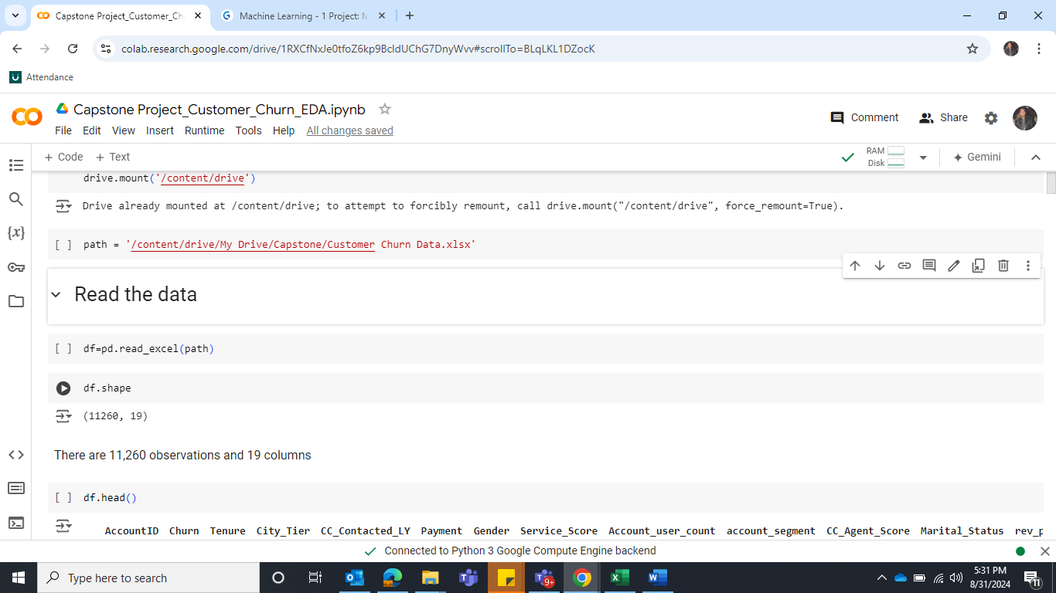

There are 11,260 observations and 19 columns

**Check the first five rows using head function**

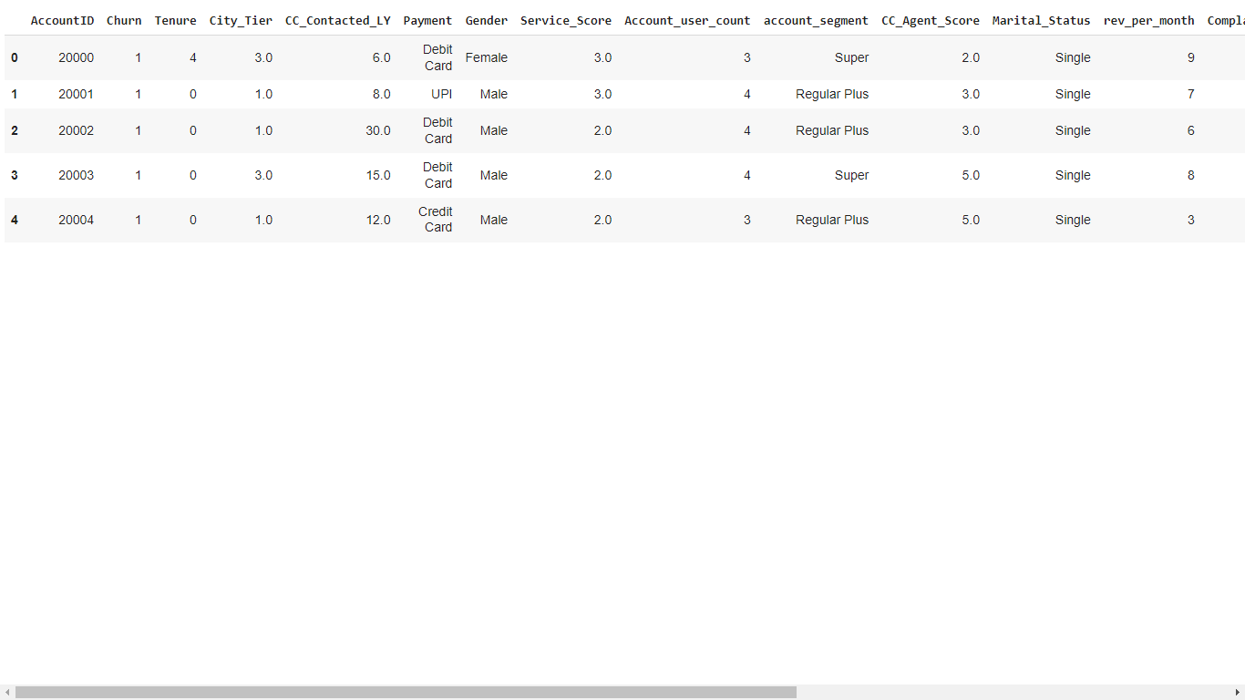

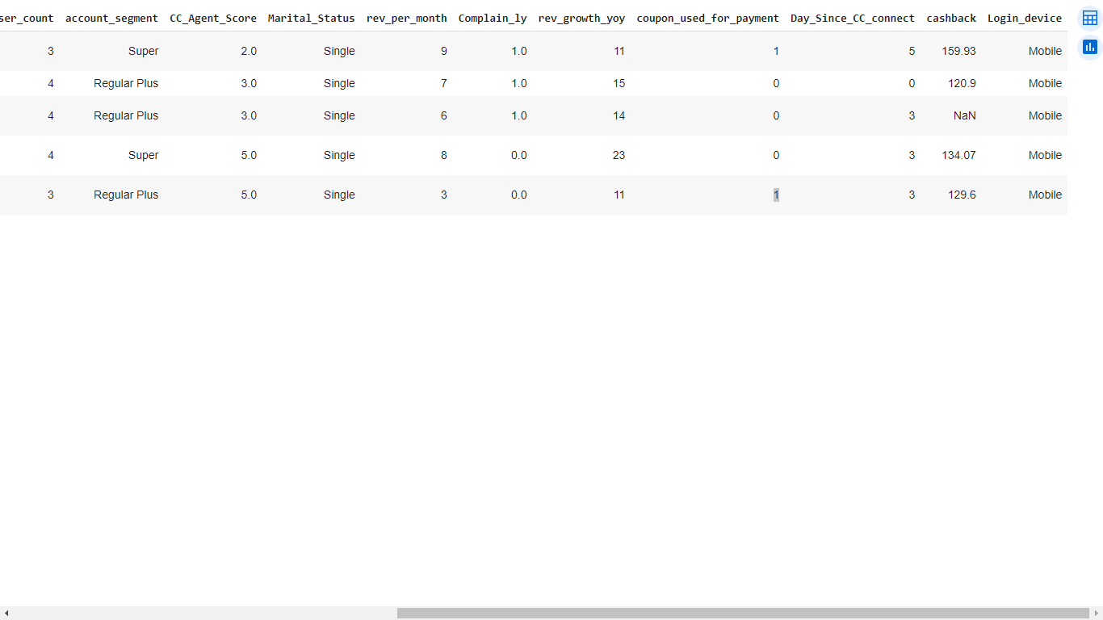

**Table 1: Top 5 rows data**

**Check the last five rows using tail function**

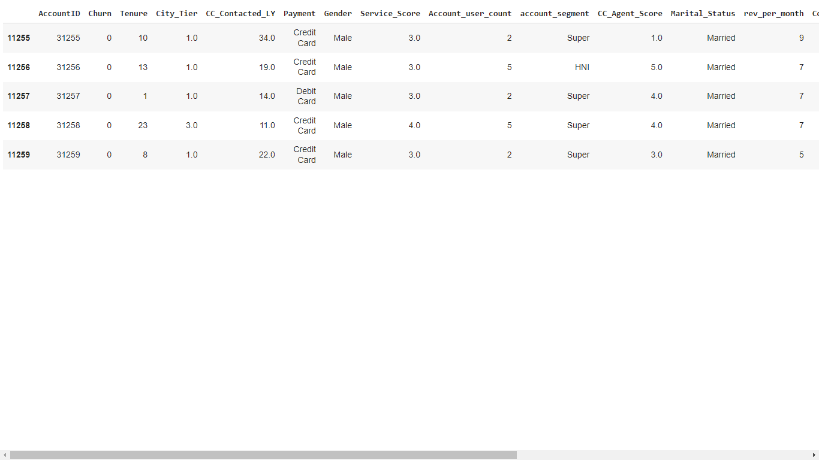

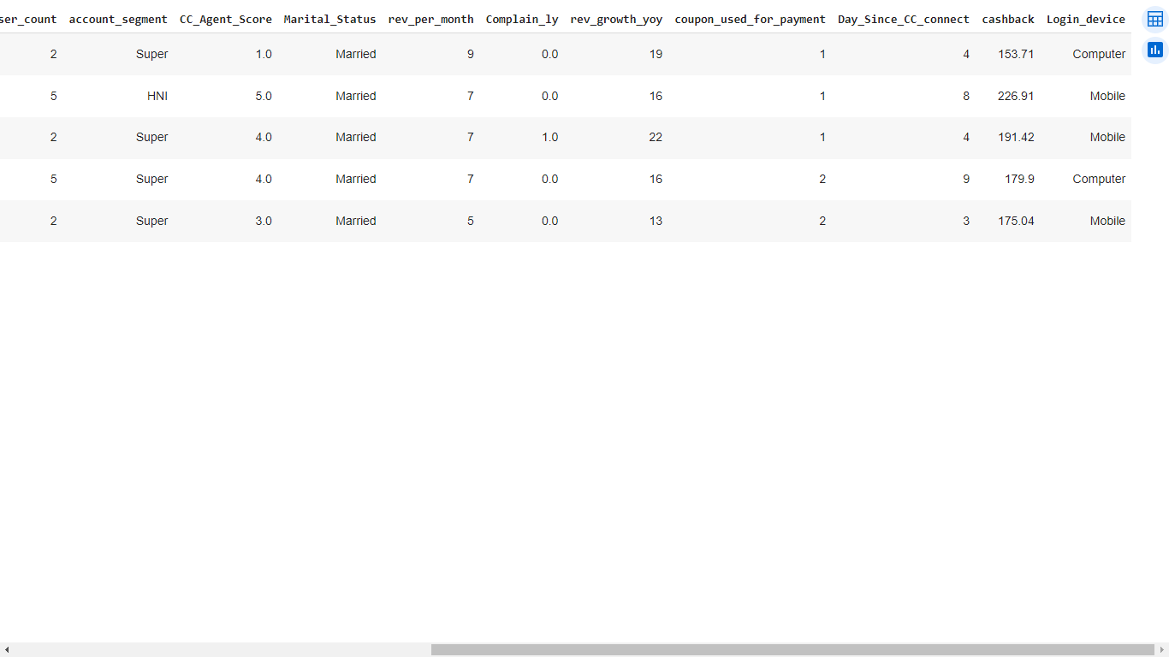

**Table 2: Last 5 rows data**

**Let’s check the datatypes Information and descriptive statistics**

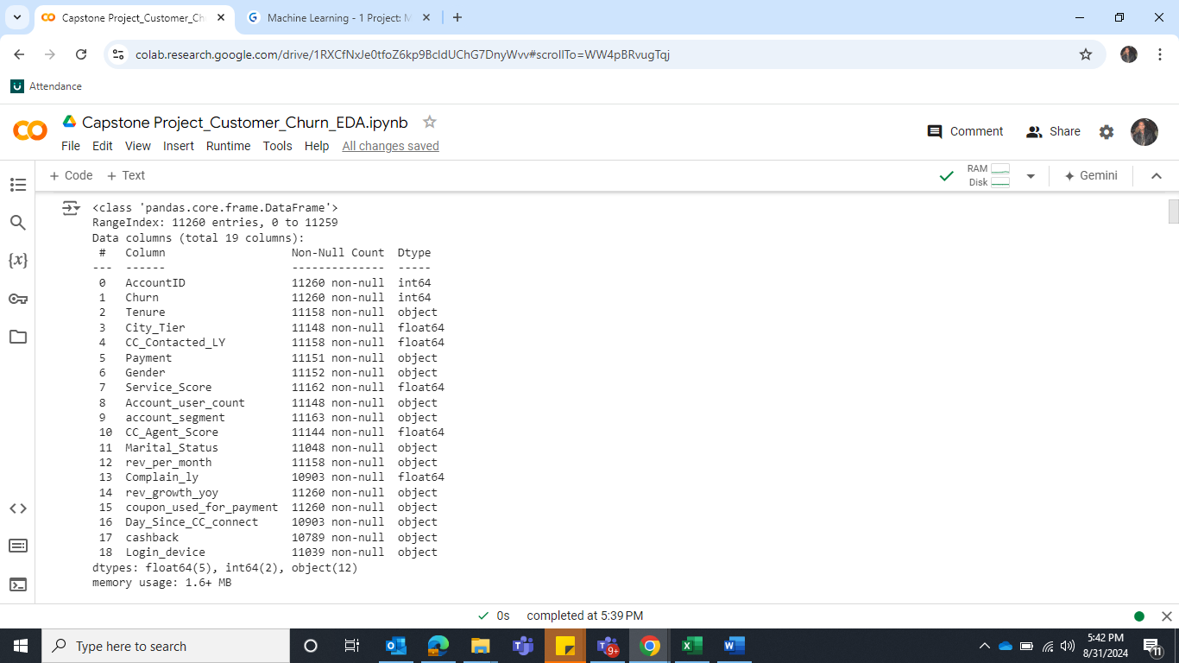

**Table 3: Datatypes information**

Insights:

* There are 11260 observations and 19 variables in the dataset. However, there are missing values as well in many columns.
* There are 5 variables float type, 12 are Object datatype and 2 are integer datatypes.

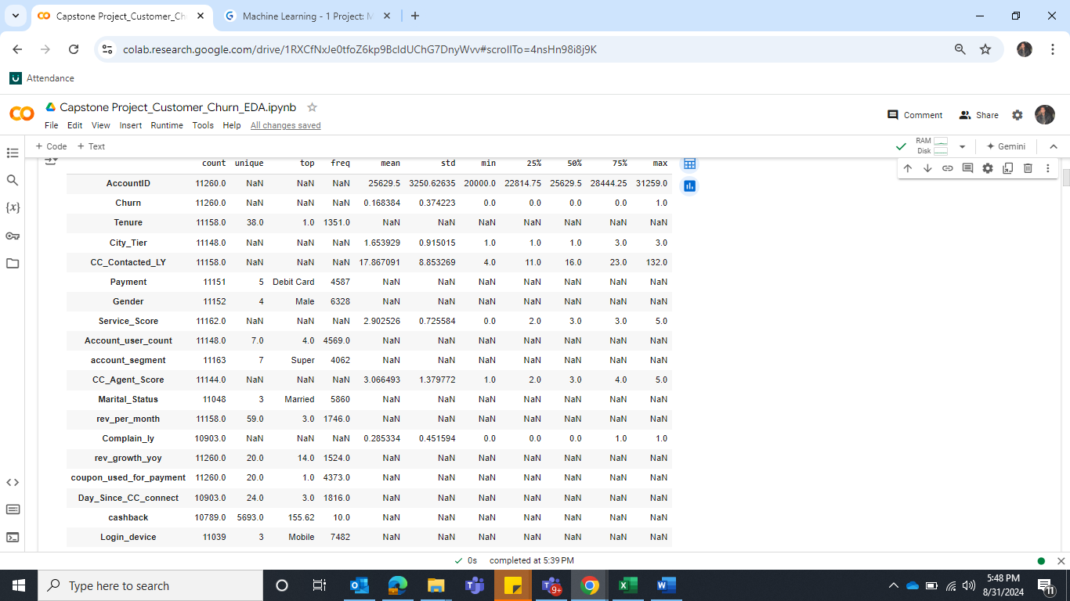

**Table 4: Descriptive statistics**

Insights:

I have included all the variables in the descriptive summary table. Because some important columns were missed as they are updated as object. There could be a chance that those columns could have special character in it. We will determine them later to know the exact reason.

1. Tenure has 38 unique values where tenure 1 has the highest frequency. This column should be present as numerical, but it is available as object. There are missing values as well.
2. Column City_Tier has 50% value is 1, 75% and Maximum value is 3. This column seems to be categorical type as nature but updated as numerical.
3. Customer contacted last year mean is 17.867091 which suggest that on average, customers has contacted to customer care 18 times in past. Standard deviation is 8.853269, Median value is 16. The 75% data value is 23.00 but maximum value is 132 which is very far to the mean as it suggests that there are some high value presents in the dataset.
4. Column Payment has 5 unique values where debit has highest frequency.
5. Gender has 4 unique values where Male has the highest frequency. There is noticeable thing that gender can not have 4 unique values. Hence, we have to check this variable which are the 4 unique variables. Will check in further steps.
6. Service_Score has minimum value is 0, 25% is 2, 75% value is 3 and maximum is 5. Satisfaction score given by customers of the account on service provided by company. So, this variable should be changed as categorial due to its nature.
7. Account_user_count, Number of customers tagged with this account. It seems that this datatype is updated as a categorial so we will be checking the reason as why it is updated as categorical.
8. Account segment, there are total 7 unique values where super has the highest frequency.
9. CC_Agent_Score, Satisfaction score given by customers of the account on customer care service. So, this variable should be changed as categorial due to its nature.
10. Marital_Status has 3 unique variables where Married has the highest frequency.
11. rev_per_month, this is a very important feature but there is no more information available in descriptive summary as this data type is updated as categorical. We will determine why it is updated as categorical.
12. Complain_ly, Any complaints has been raised by account in last 12 months. It has 0 and 1, 0 means no and 1 means yes.
13. Columns **rev_growth_yoy**, **coupon_used_for_payment, Day_Since_CC_connect and cashback:** There are no more information available in descriptive summary for these columns as their data types are updated as categorical. We will determine why it is updated as categorical.
14. Column Login_device, has 3 unique values where Mobile has the highest frequency.

*Let’s check irregularities in the data*

Upon checking, Column Gender It is observed that there is inconsistency found in data. Male is updated in two way as “Male or M”, Similarly, Female is also updated in two way as Female or F. hence, we will keep consistent this column and replace all Male keyword to “M” and all Female keyword to “F”.

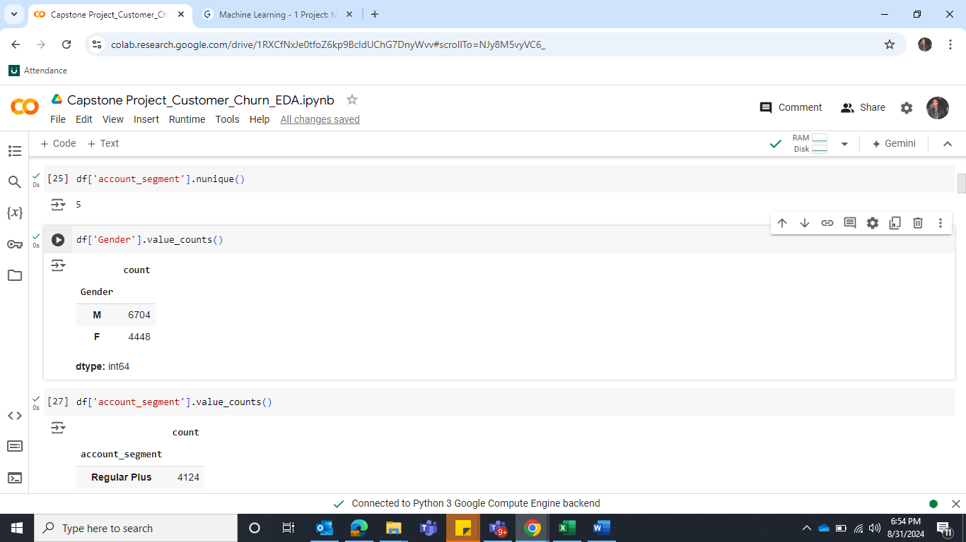

Similarly, Column account segment has inconsistency as there are two values updated for Regular Plus and Regular +, Super Plus and Super +. Hence, we will make this column consistent by replacing Regular + to Regular plus and Super + to Super Plus.

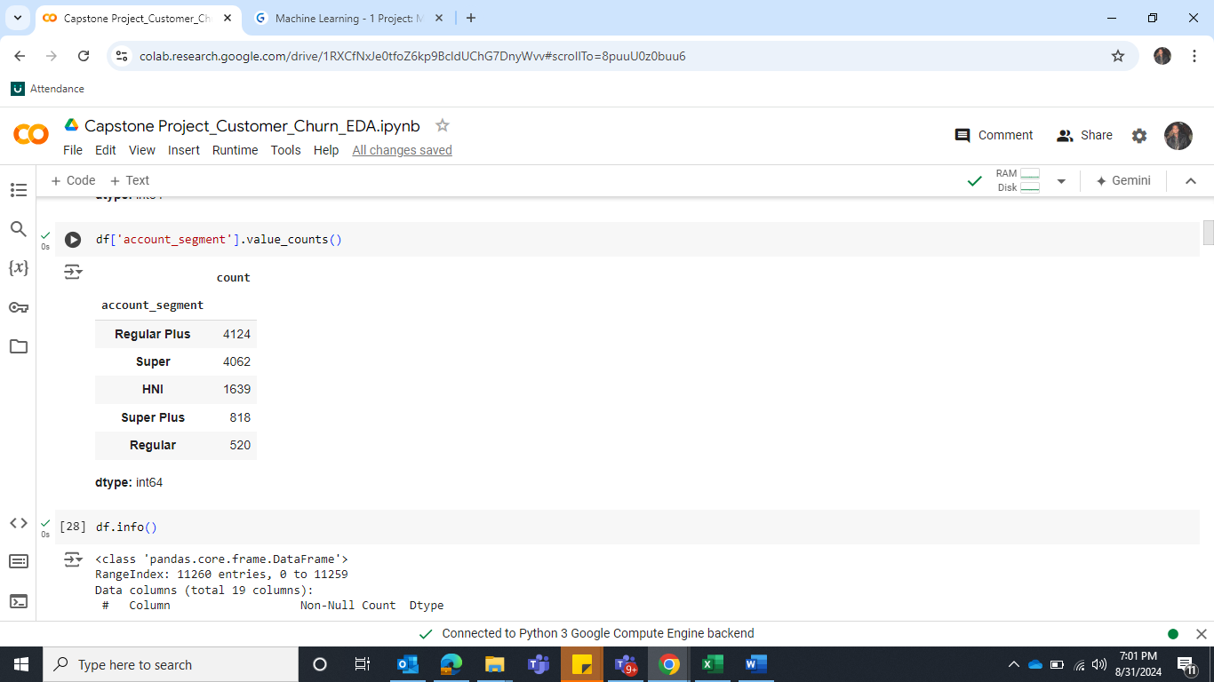

Let’s check the following columns to determine why they are updated as categorical since their nature are numerical.

1. TENURE
2. ACCOUNT_USER_COUNT
3. REV_PER_MONTH
4. REV_GROWTH_YOY
5. COUPON_USED_FOR_PAYMENT
6. DAY_SINCE_CC_CONNECT
7. CASHBACK

After reviewing these columns, it is observed that they have special character [$#@+*&]. Therefore, we will replace this special character with null values.

Checking missing values

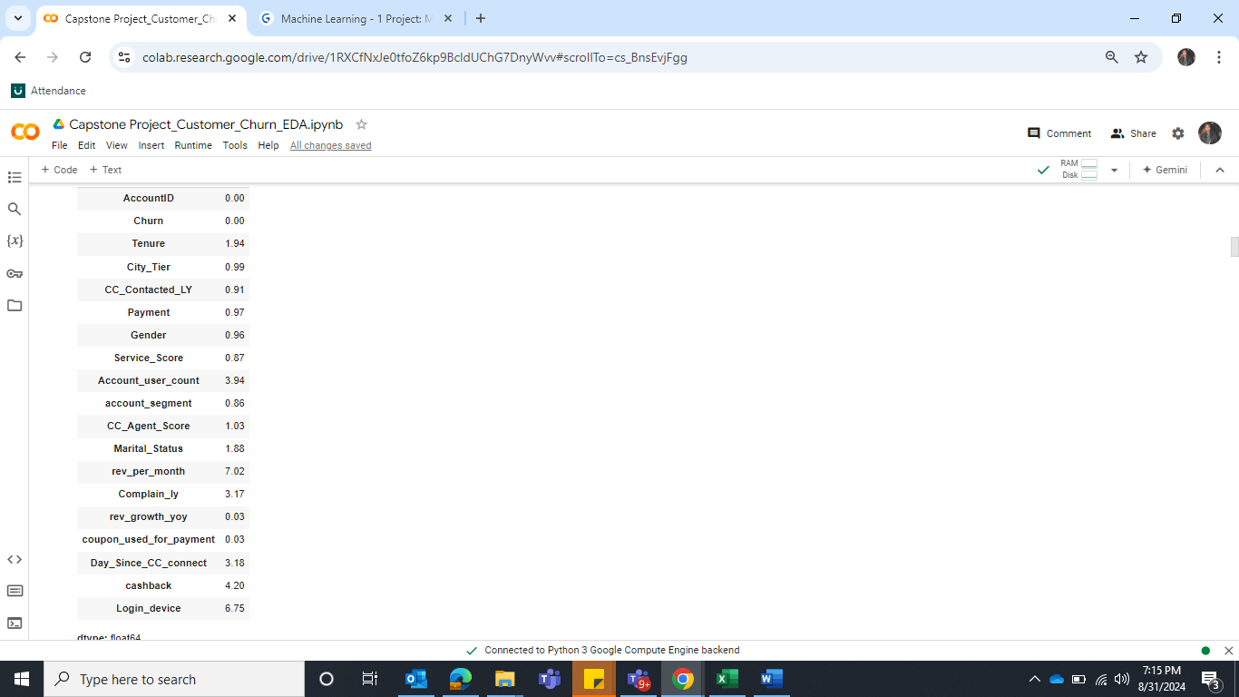

**Table 5: Sum of Missing values**

There are missing values present in each column except Account id and Churn. Login device has the highest missing values approx. 7%.

Let’s drop the column **AccountID** since it does not provide any help with prediction.

**Checking duplicate rows:** Upon checking the duplicate, there are no duplicate rows.

Let’s change those columns which are categorical by nature but present as numerical in the database.

**2. EDA - Univariate / Bi-variate / multi-variate analysis to understand relationship b/w variables. - Both visual and non-visual understanding of the data.**

A) Univariate analysis of numerical columns

**Tenure**

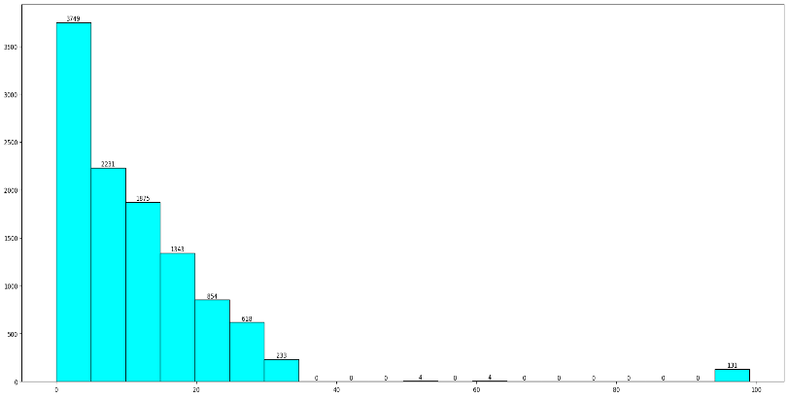 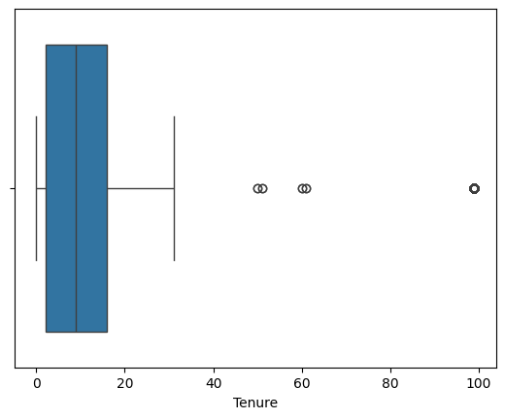

**Figure 1: Histogram of Tenure Figure 2: BoxPlot of Tenure**

**Observation**

1. The mean of tenure is 11.025086 which means that on average, the customer has been associated with service for approx. 11 months.
2. The minimum value is 0, which suggest that some customers have recently joined.
3. 25% of customers have 2 months tenure and 50% of customers have a 9-months tenure.
4. 75% of customers are associated with the service for 16 months tenure.
5. Maximum tenure is 99 which is approx. 8 years. The data has right skewed and has outliers in dataset.

**CC_Contacted_LY**

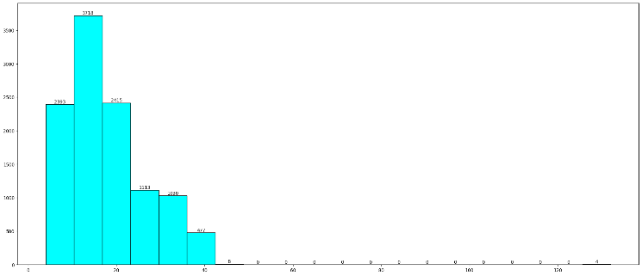 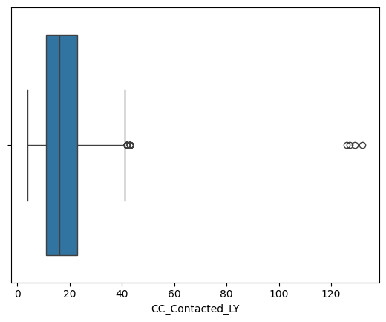

**Figure 3: Histogram of Contacted_LY Figure 4: Boxplot of Contacted_LY**

**Observation**

1. Customer contacted last year mean is 17.867091 which suggests that on average, customers has contacted to customer care 18 times in past.
2. The 75% data value is 23.00 but maximum value is 132, which is very far to the mean as it suggests that there are some high value presents in the dataset.

**Account_user_count**

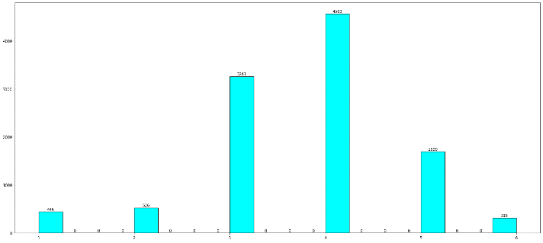 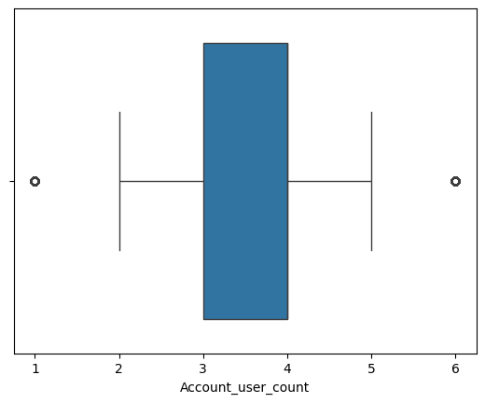

**Figure 5: Histogram of Account user count Figure 6: Boxplot of Account user count**

**Observation**

1. The average customers are tagged with an account is approx. 4.
2. The minimum customer tagged with an account is 1. 25% account has 3 customers.
3. 50% and 75% accounts have 4 customers. The maximum account has 6 customers

**rev_per_month**

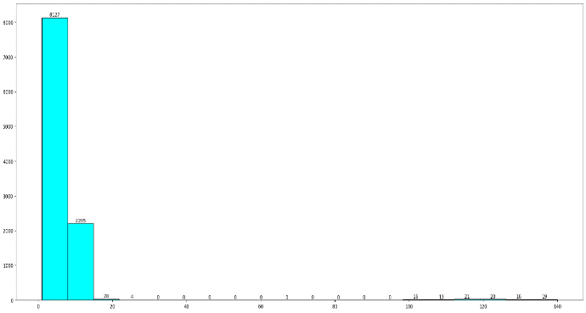 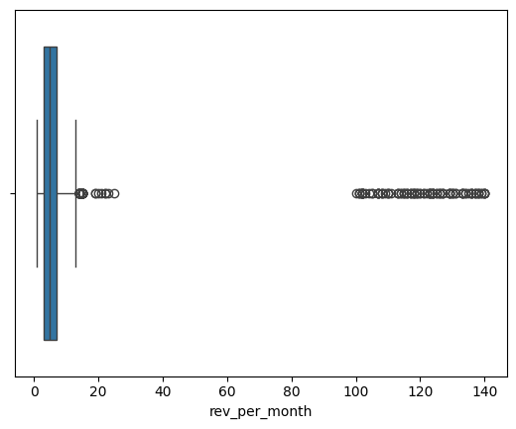

**Figure 7: Histogram of Revenue per month Figure 8: Boxplot of Revenue per month**

**Observation**

1. The mean value of monthly average revenue is 6.37. The standard deviation of 11.91 indicates significant variability in the monthly average revenue across different accounts. Some accounts generate much higher revenue than others, leading to a widespread in the data.
2. The minimum monthly average revenue is 1, 25% monthly average revenue value is 3 and 50% and 75% monthly average revenue values are 5 and 7.
3. The maximum monthly average revenue is 140 which means that there are extremely higher revenue value customers.

**rev_growth_yoy**

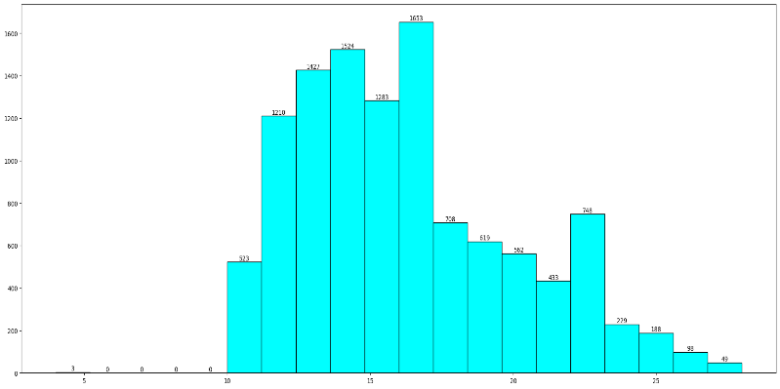 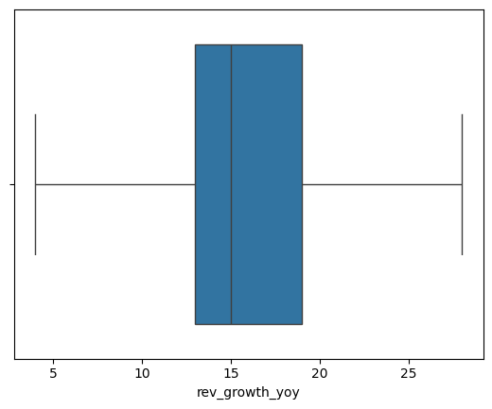

**Figure 9: Histogram of rev_growth_yoy Figure 10: Boxplot of Revenue growth yoy**

**Observation**

1. The mean value of revenue growth percentage of the account is 16. The standard deviation of 3.757721, indicating moderate variability in the data. The values are spread around the mean, but not too widely.
2. The minimum revenue growth percentage of the account is 4.
3. 25% monthly revenue growth percentage of the account is 13 and 50% and 75% revenue growth percentage of the account are 15 and 19.
4. The maximum revenue growth percentage of the account is 28. By seeing boxplot, there is no outlier present in data.

**Coupon_used_for_payment**

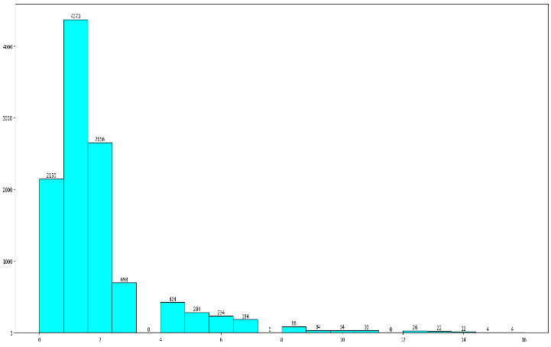 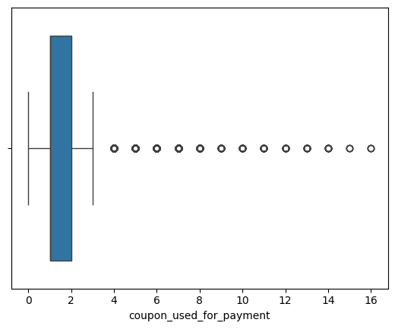

**Figure 11: Histogram of coupon_used_for_payment Figure 12: Boxplot of coupon_used_for_payment**

**Observation**

1. The average of coupon_used_for_payment by customer is approx. 2 coupons.
2. The minimum coupon used is 0. This means that there are few customers who never used any coupon.
3. There are 50% of customers who have used 1 coupon, 75% of customers have used 2 coupons.
4. Maximum coupons are used 16.

**Day_Since_CC_connect**

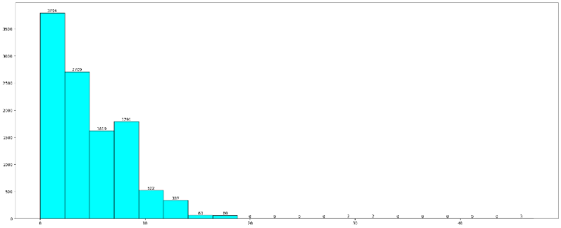 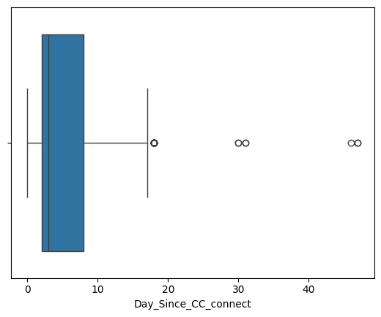

**Figure 13: Histogram of Day_Since_CC_connect Figure 14: Boxplot of Day_Since_CC_connect**

**Observation**

1. The average number of 4.63 days since no customers in the account has contacted customer care.
2. The minimum coupon used is 0. This means that there are few customers who never used any coupon, There are 50% of customers who have used 1 coupon and 75% of customers have used 2 coupons, Maximum coupons are used 16.

**Cashback**

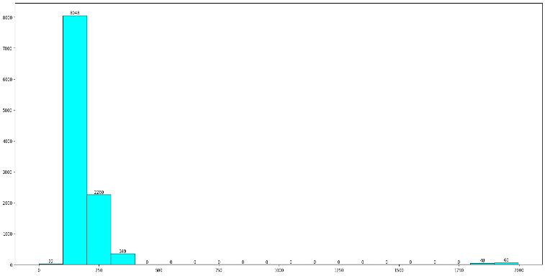 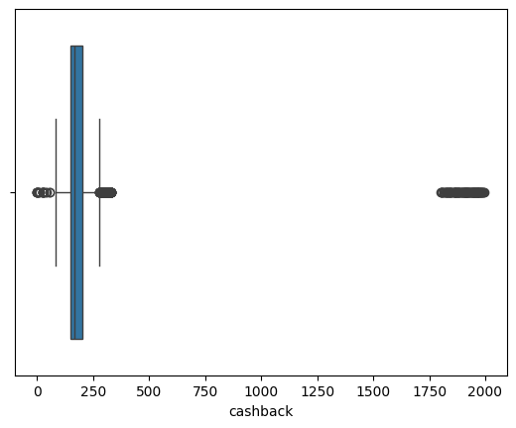

**Figure 15: Histogram of Cashback Figure 16: Boxplot of Cashback**

**Observation**

1. The average monthly average cashback is approx. 196.
2. The minimum monthly average cashback is 0. This means that there are few customers who never received cashback, 75% of customers have monthly average cashback received 200.
3. The maximum cashback amount is 1997, indicating a significant outlier.

B) Univariate analysis of categorical columns

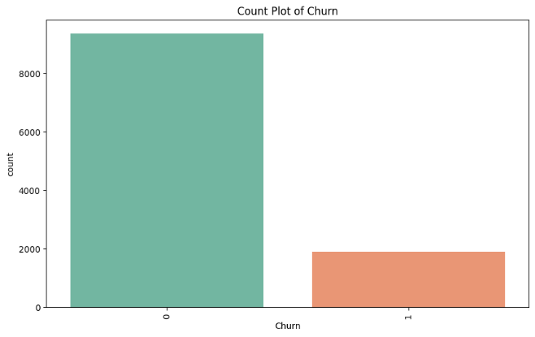

**Observation**

Churn is the target variable and there are 83% customers non-churners, and 17% customers are about to churn. Instances of one of the two classes is higher than the other, in another way, the number of observations is not the same for all the classes in a classification dataset. This means that data is unbalanced.

**Figure 17: Countplot of Churn**

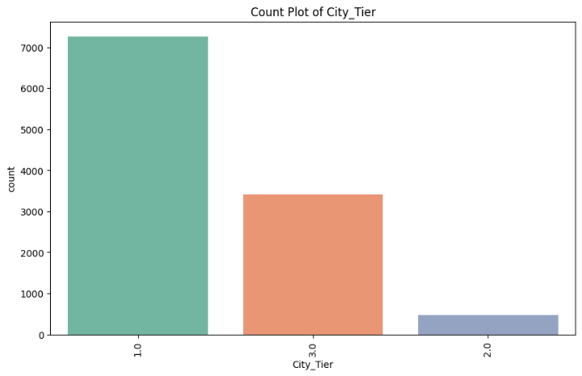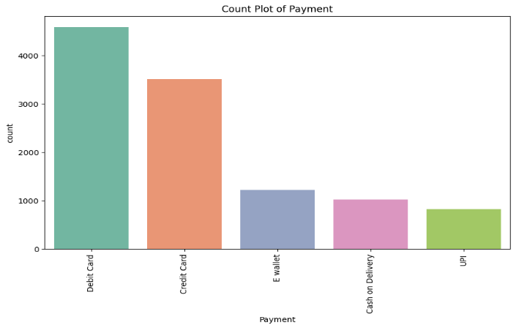

**Figure 18: Count plot of City Tier Figure 19: Count plot of Payment**

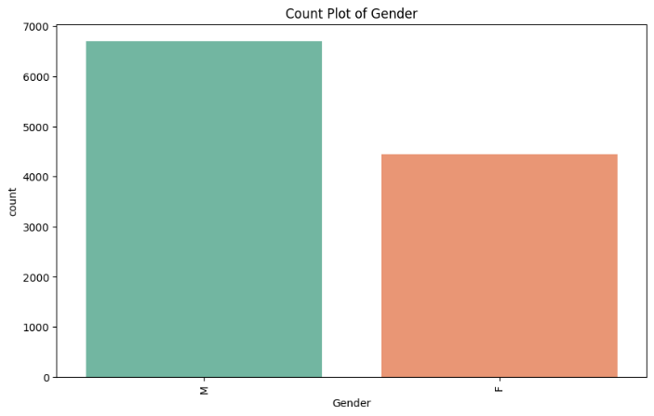 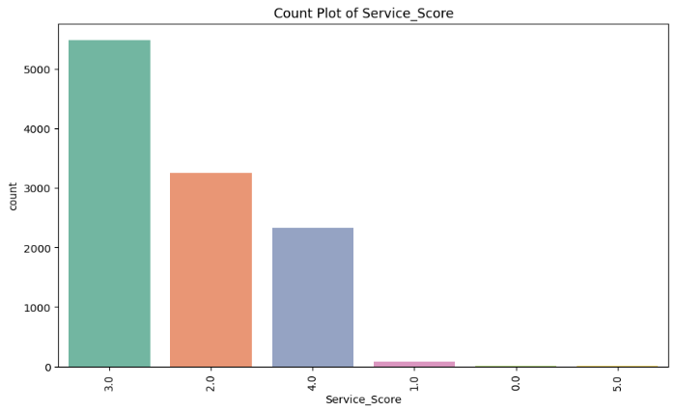

**Figure 20: Count plot of Gender Figure 21: Count plot of Service score**

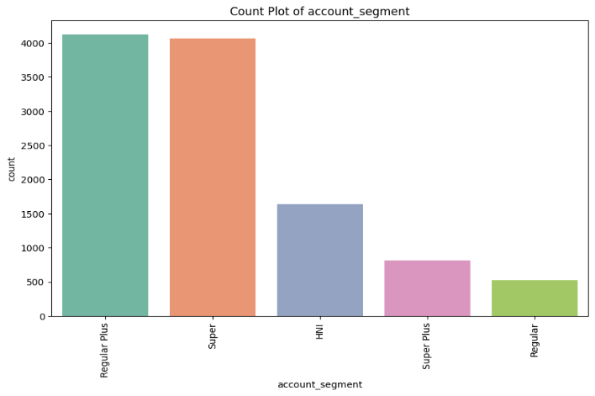 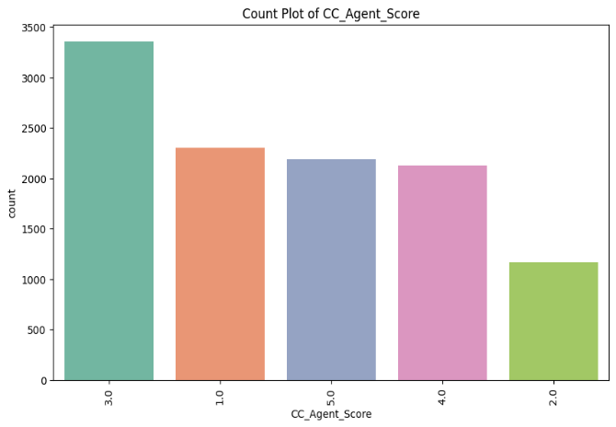

**Figure 22: Count plot of Account segment Figure 23: Count plot of CC_Agent_score**

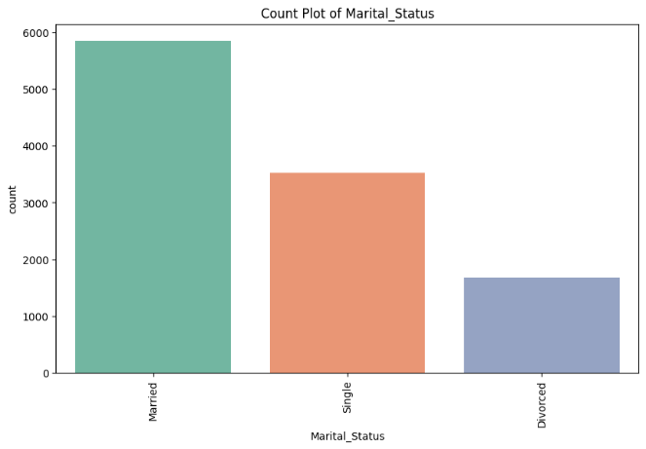 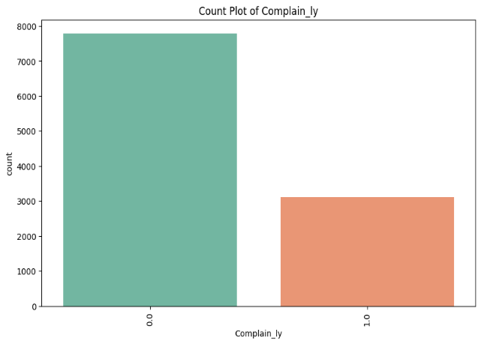

**Figure 24: Count plot of Marital status Figure 25: Count plot of complain ly**

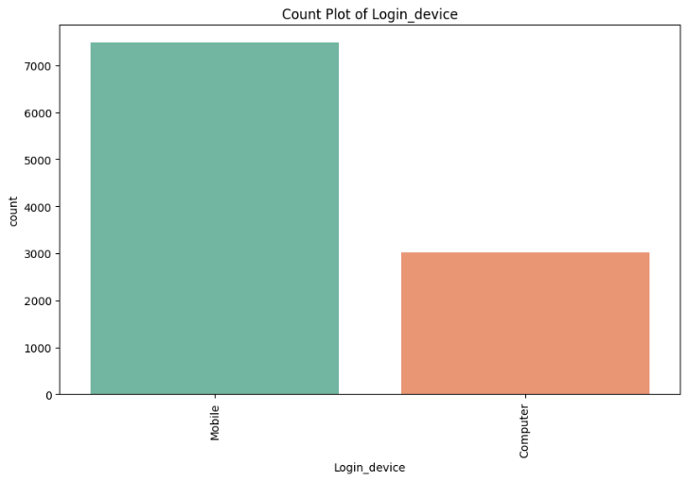

**Figure 26: Count plot of Login device**

C) Bivariate Analysis

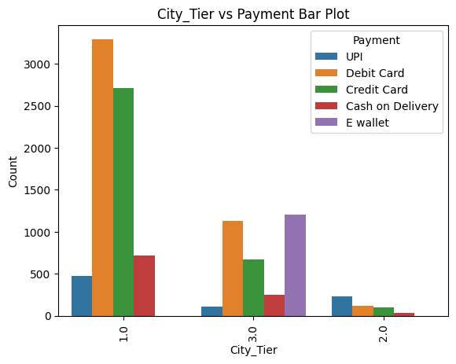 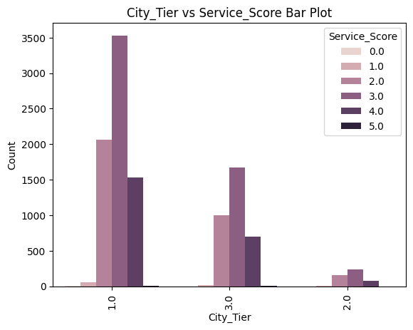

**Figure 27: Bar plot of City tier vs Payment Figure 28: Bar plot of City tier vs Service score**

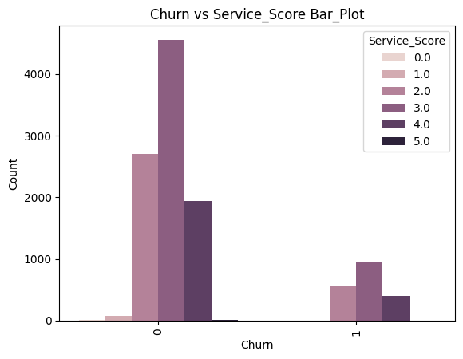 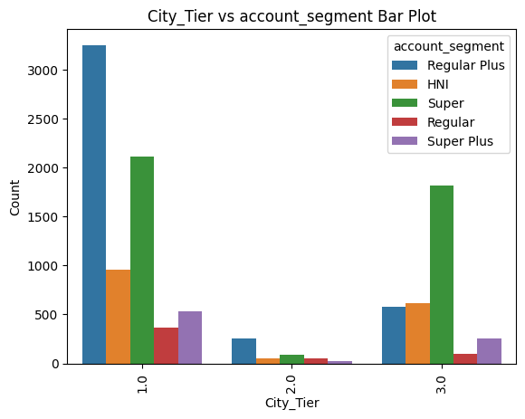

**Figure 29: Bar plot of churn vs Service score Figure 30: Bar plot of City tier vs account segment**

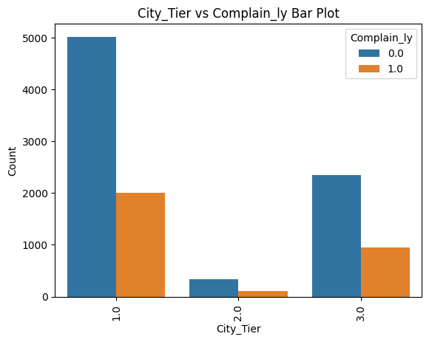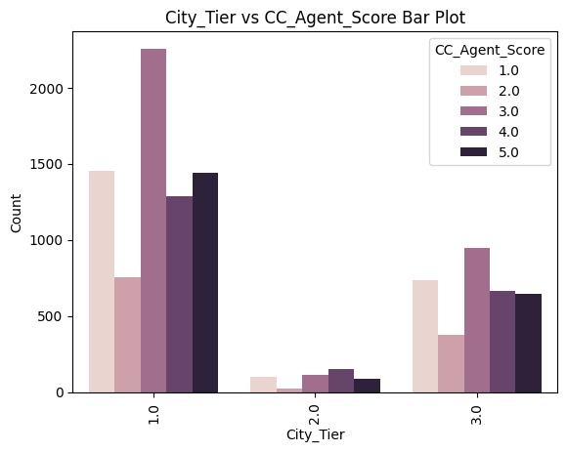**Figure 31: Bar plot of City tier vs complain raised Figure 32: Bar plot of City tier vs CC_agent score**

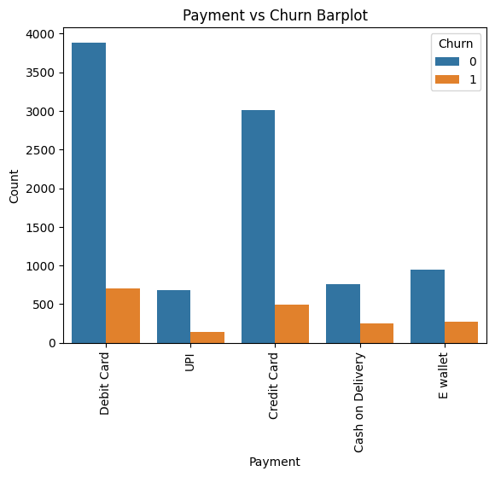 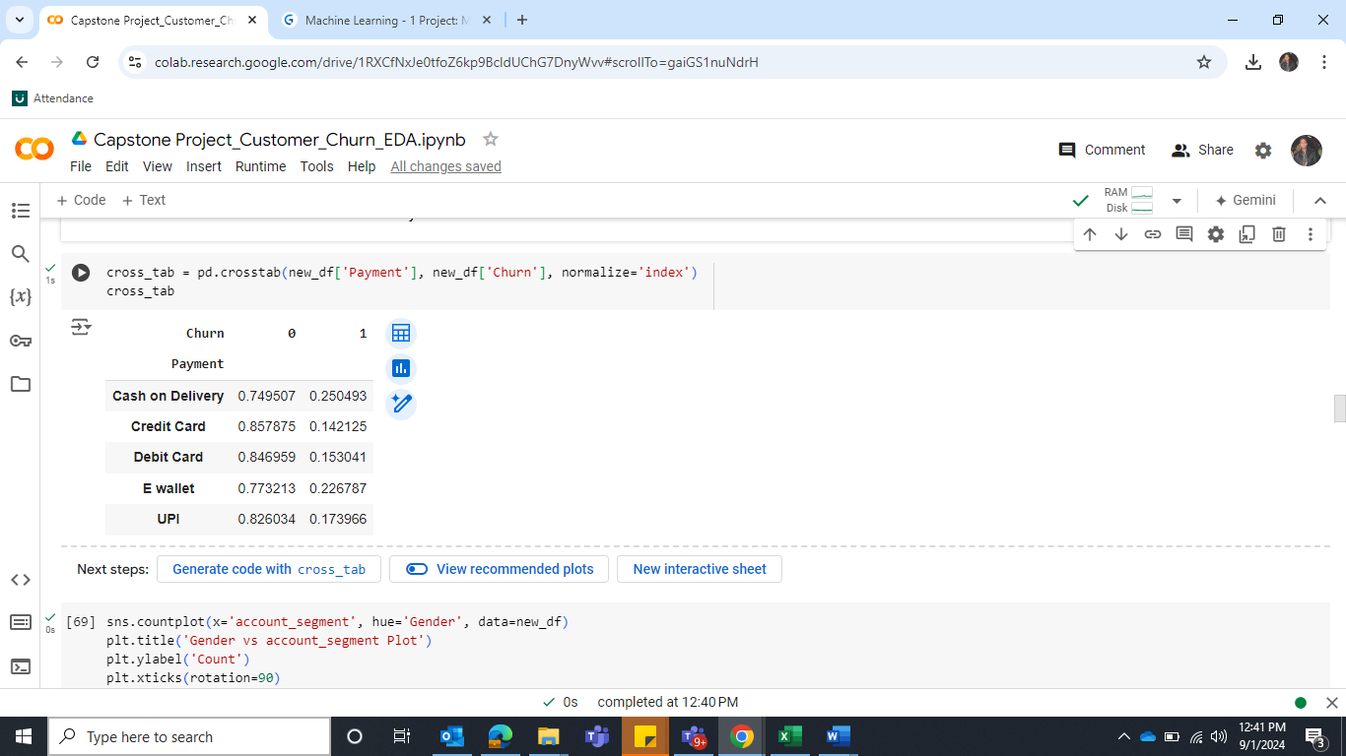

**Figure 33: Bar plot of Payment vs Churn Table 6: Payment vs Churn**

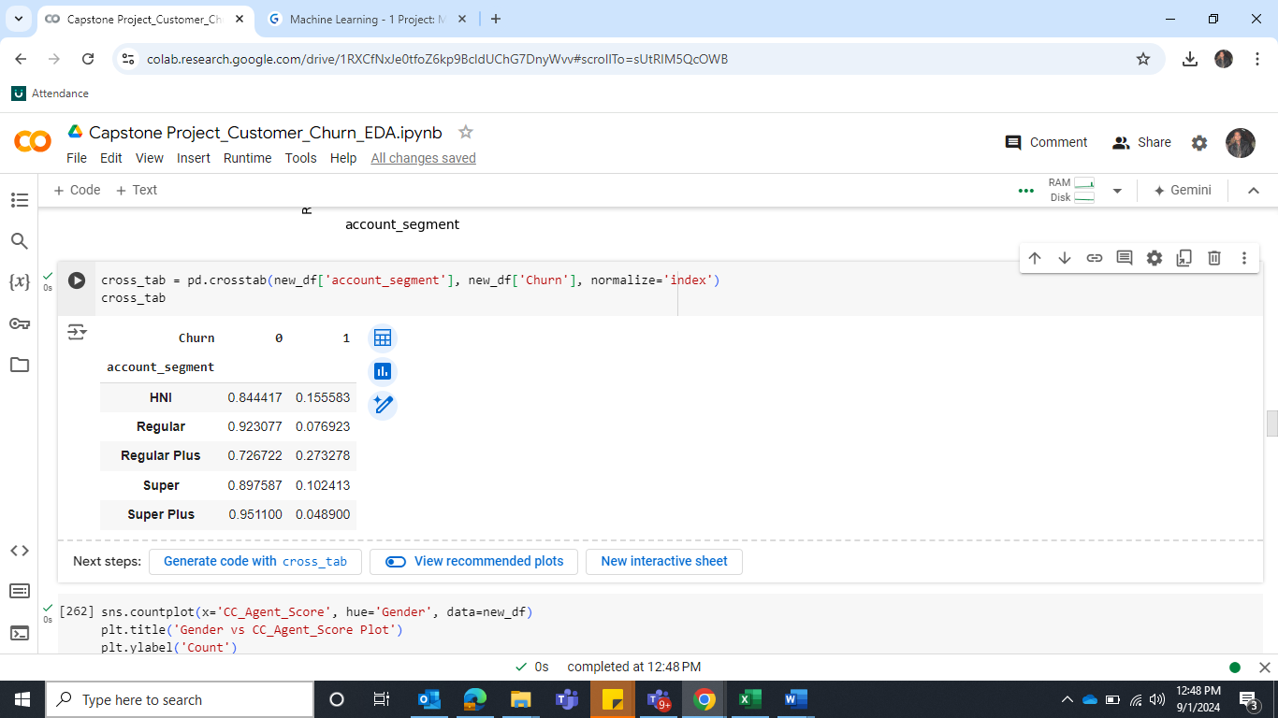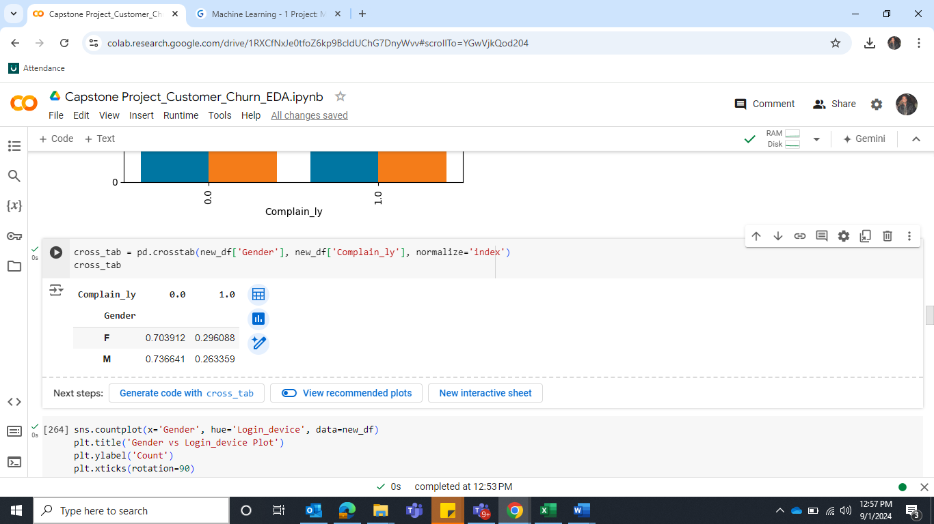

**Table 7: Account segment vs Churn Table 8: Gender vs Complain_ly**

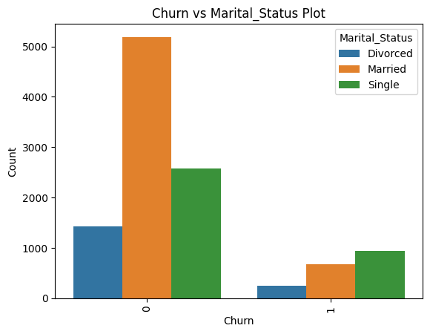 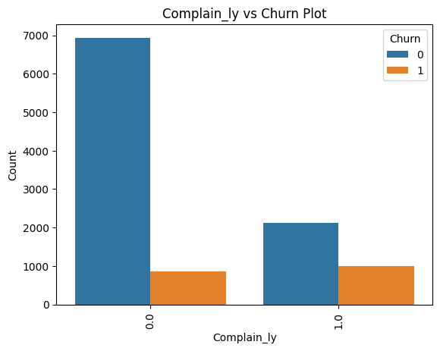

**Figure 34: Bar plot of Marital status vs Churn Figure 35: Bar plot of Complain vs Churn**

**Observation**

1. There are more population from tier 1 cities then tier 3 cities and the lowest number of tier 2 cities.
2. Debit card is the most preferred mode of payment then credit card is in second place. E-wallet is at third place, cash on delivery is at fourth place and UPI is the least mode of payment has used by the customers.
3. There are more number of male customers than female.
4. The most satisfaction score is given 3 by customers on service provided by company. Then score 2 has given after score 3, score 4 is standing at 3 places. The least satisfaction score is given 5.
5. Regular plus account has more number of spend and Super has the second highest in the list. HNI is standing at third place, Super plus account is at 4th place. Regular is standing at last place.
6. Satisfaction score 3 given by customers of the account on customer care service provided by company is the highest then score 1 is placed at second place.
7. There are maximum population of customers are married then second highest customers are single and least population of customers are divorced.
8. There are more numbers of non-complaints than complaints.
9. Customers have used mobile devices rather than computer devices.
10. Tier 1 city customers have used Debit cards and credits cards more. They even did not use E wallet as payment mode.
11. Tier 3 city customers have used E wallet more, then debit card and credit card. They have used UPI is the least mode of the payment.
12. Tier 2 city customers have not used E wallet but have used more UPI than other mode of payment.
13. 28% of customers of Tier 1 and Tier 3 city have raised the complaints.24% of customers of Tier 2 have raised the complaints.
14. Tier 1 customers have given the highest score of 3 to customer care agent.
15. Tier 2 customers have given the highest score 4 to customer care agent.
16. Tier 3 customers have given the highest score 3 to customer care agent.
17. Cash on delivery and E Wallet customers are more likely to churn.
18. Regular plus customers are more likely to churn.
19. Super plus and Regular customers have less numbers of churn people.
20. 29% of females out of females are like to churn. Similarly, 26% of males are like to churn.
21. Single people are more to churn.
22. 52% of customers who raised a complain are likely to churn.

D) Bivariate Analysis for Categorical and Numerical

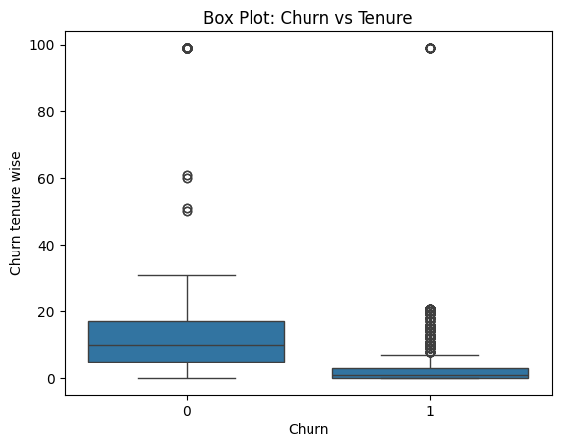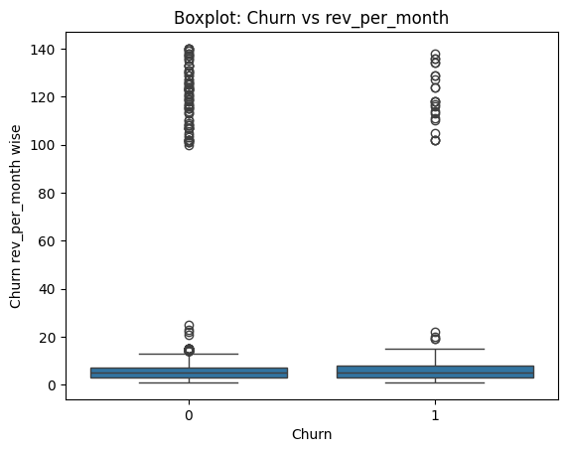

**Figure 36: Box plot of Tenure vs Churn Figure 37: Box plot of Revenue per month vs Churn**

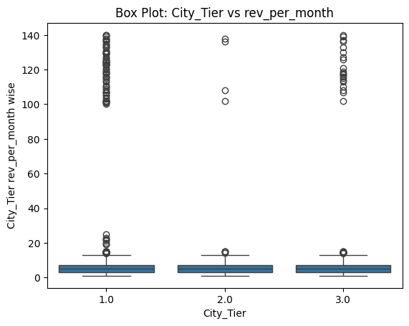 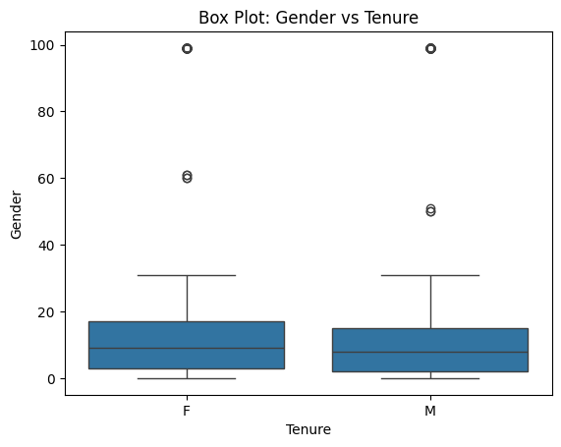

**Figure 38: Box plot of City Tier vs Revenue per month Figure 39: Box plot of Gender vs Tenure**

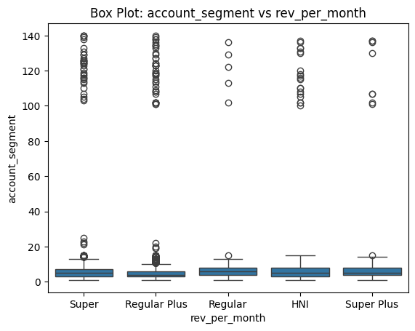

**Figure 40: Box plot of Account segment vs Revenue per month**

**Observation**

1. The median of non-churners is higher than churners. Non-churners distribution is wider, which suggests that non-churners customers’ tenure is longer than churners. Hence, customers who have small tenure are more likely to churn.
2. The distribution of both churners and non-churners is very tight, which indicates that both groups’ revenue is low. However, both groups have some customers whose revenue is high which are considered as outliers.
3. The distribution of each Tier looks similar, and all Tier have the outliers. However, Tier 1 and Tier 3 have a greater number of outliers than 2.
4. The median of female tenure distribution is slightly higher than male which indicates that Female tenure is slightly longer than male.
5. All groups distribution looks same, the median of regular category seems to be high than others and Regular median looks the lower among all.

E) Multivariate Analysis

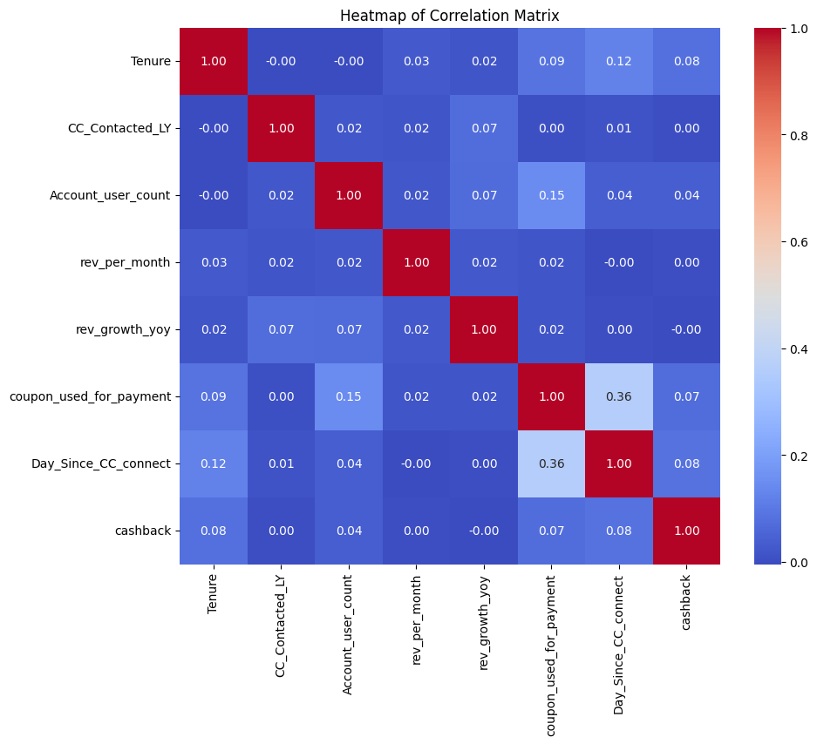

**Figure 41: Heatmap**

**Observation**

Most of the correlations in the matrix are close to zero, indicating weak or no linear relationship between the variables. This suggests that, in terms of linear relationships, multicollinearity may not be a significant concern in the data.

**Data Cleaning and Pre-processing - Approach used for identifying and treating missing values and outlier treatment (and why) - Need for variable transformation (if any) - Variables removed or added and why (if any**

Missing Value Treatment

1 - *The following columns are treated with median for missing values.*

1. Tenure
2. CC_Contacted_ly
3. Account_user_count
4. rev_growth_yoy
5. coupon_used_for_payment
6. Day_Since_CC_connect
7. Cashback
8. Account_user_count

*2 - The following columns are treated with mode for missing values.*

1. City_Tier
2. Payment
3. Gender
4. Service score
5. Account Segment
6. Marital_Status
7. Complain_ly
8. Login_device

*3 – Below column is treated with KNN Imputer for missing values.*

1. rev_per_month

Outliers check and Treatment

*Before checking and treating the outliers, let’s make two different data frame and copy all the independent variables to one dataframe and copy the target variable to another dataframe.*

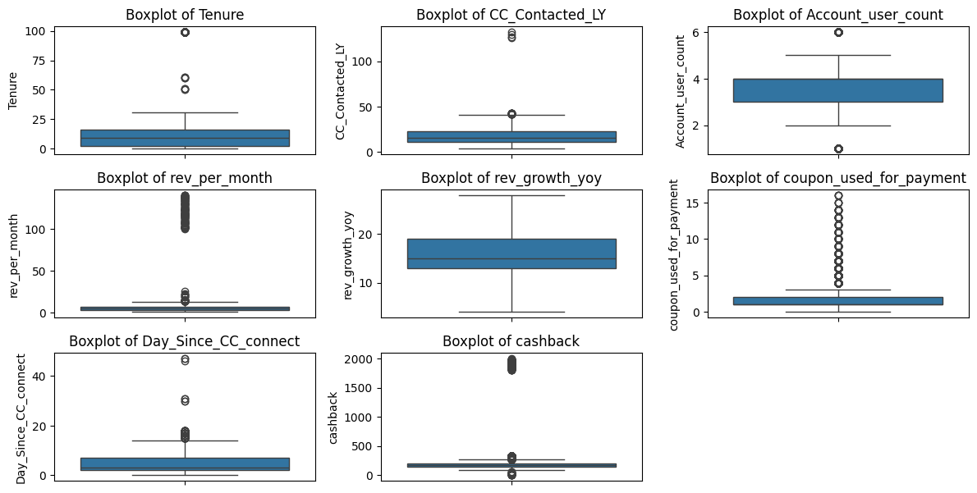

**Figure 42: Checking outliers of numerical variables**

**Observation**

We will check the outliers in numerical variables only as it does not make any sense to check for categorical variables. There are outliers present in column Tenure, CC_Contact_Ly, Account_user_count, Revenue per month, coupon used for paymen, Day since customer care connect and Cashback.

Based on 25 and 75 percent of Quantile, let’s count of outliers in each column.

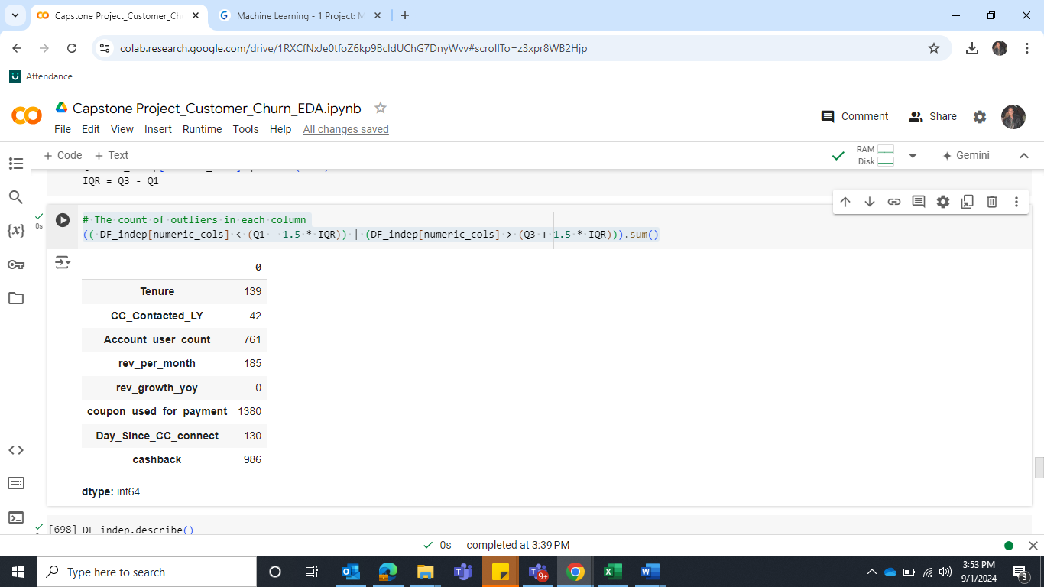

**Table 9: Checking outliers in each row**

Let’s remove the outliers with upper range and lower range with following formulas.

IQR=Q3-Q1

lower_range= Q1-(1.5 * IQR)

upper_range= Q3+(1.5 * IQR)

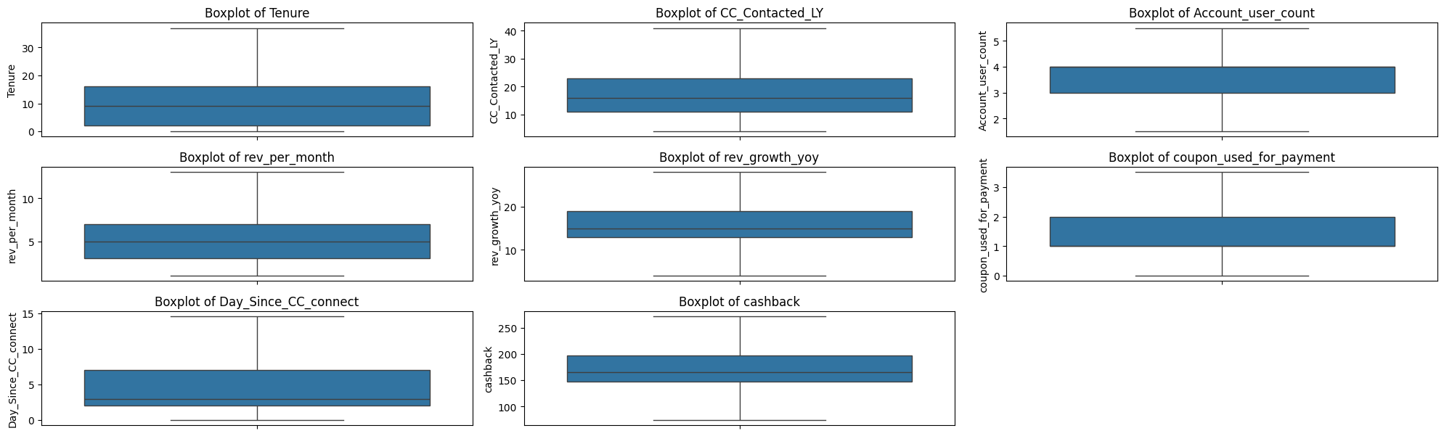

**Figure 43: Checking outliers of numerical variables after treatment**

Variable transformation - Let’s do the encoding for the following variables. Since they are categorical variables and we cannot perform most statistical operations on a string variable, hence we want to turn the string variable into a numeric variable.

1. Column Gender and Login_device has encoded with Label Encoding
2. Column account_segment' has encoded with ordinal encoding as Regular will be marked as 1, Regular plus 2, Super will be 3, Super plus will be marked as 4 and HNI will be marked as 5.
3. Payment', 'Marital_Status' has encoded with One-Hot Encoding.

Now we see that there are different different dimensions in many variables, so we have to bring variables to the same scale, to have a mean of 0 and standard deviation is 1.

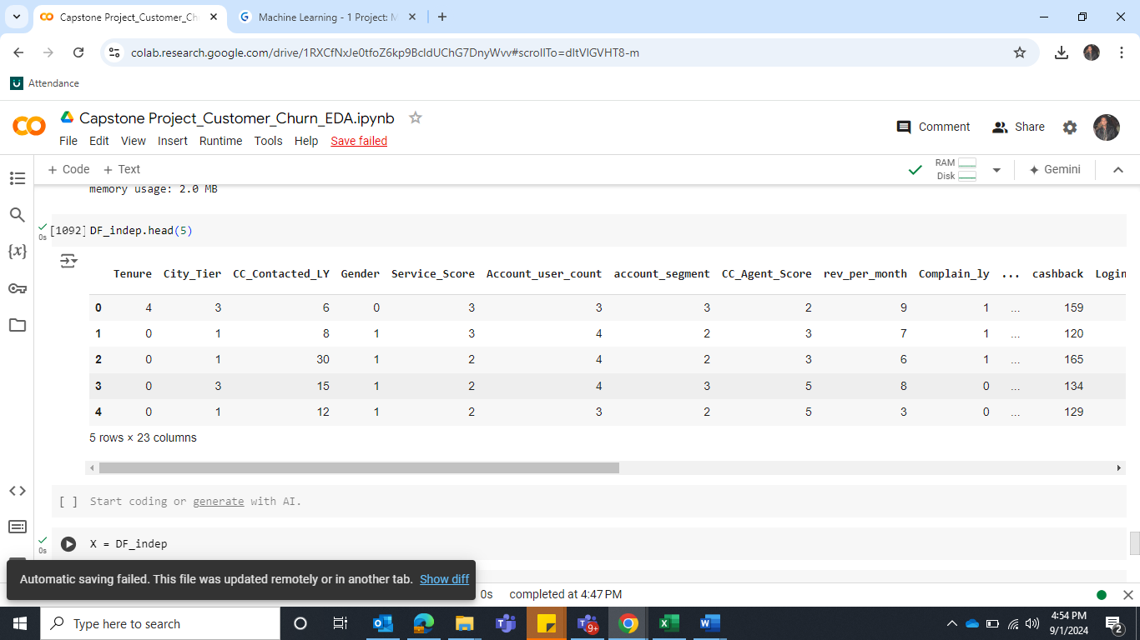

**Table 10: Top 5 rows of data before Scale**

*Let’s scale the data with the help of StandardScaler from sklearn.*

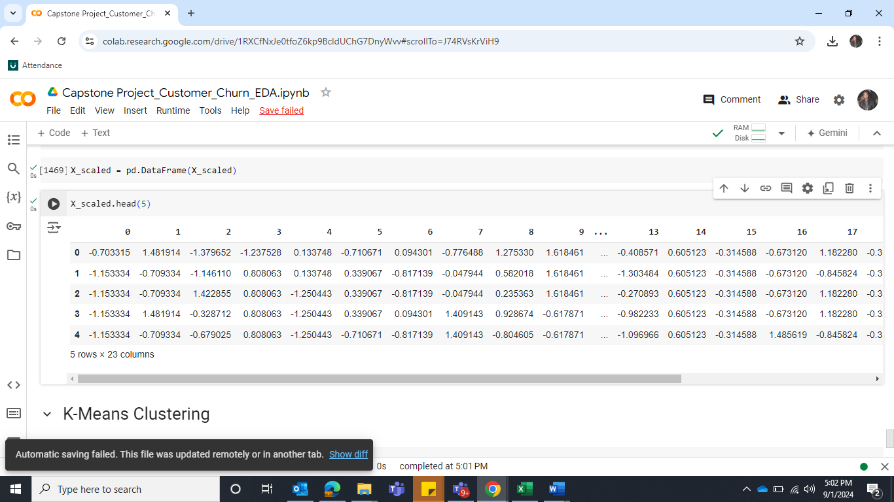

**Table 11: Top 5 rows of data after Scale**

Any business insights using clustering (if applicable)

Let’s use K-means clustering to analysis it. Import Kmeans class from Sklearn.cluster

Define and fit it. Let’s take the range of clusters from cluster 1 to 10. Below is their WSS value.

Plot the elbow graph

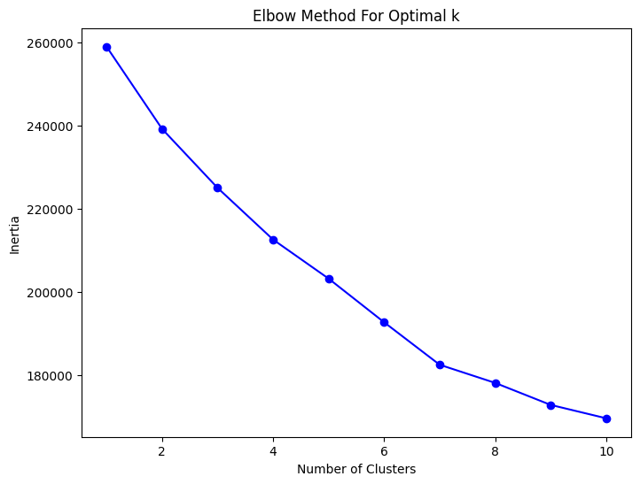

[258980.0,

239195.73013495476,

225001.912110479,

212562.35119540992,

203172.57203006613,

192669.4632499222,

182453.89372649192,

178084.90560201273,

172790.1932826128,

169571.50007504848

**Figure 44: Elbow method graph**

**Observation**

By looking at the graph, it is observed that after cluster 2 there is a sharp decrease and WSS value also suggests that there is sharp decrease after cluster 2. So, optimal cluster should be 2. But we will test it via **silhouette_score**

For n_clusters=2, the silhouette score is 0.08177977431118202

For n_clusters=3, the silhouette score is 0.09597583323474008

For n_clusters=4, the silhouette score is 0.11480622814632428

For n_clusters=5, the silhouette score is 0.09610019270952365

For n_clusters=6, the silhouette score is 0.10979395181709525

For n_clusters=7, the silhouette score is 0.12083424969768668

For n_clusters=8, the silhouette score is 0.10648497733148284

For n_clusters=9, the silhouette score is 0.1144965176893292

For n_clusters=10, the silhouette score is 0.11064100513733281

After testing the silhouette, it is observed that cluster 7 has the highest score and then cluster 4 has the second highest score.

The Elbow Method suggests that cluster 2 might be optimal based on the WSS values, indicating a balance between simplicity and cluster quality. However, silhouette analysis suggests 7 clusters offer the best separation. Cluster **interpretability** is critical and cluster 7 would be hard to interpret for business insights. Let’s go with cluster 4, Based on the silhouette scores, cluster 4 (silhouette score of 0.115) offers a better-defined structure than clusters 2 and 3, and is still manageable from a business perspective. It strikes a balance between cluster quality and interpretability.

Cluster 4 inertia value is 212562.35119540992. Let’s add a column by the name of “Clusters” and assign their cluster labels. Combine Column Churn with the dataset and review the dataset.

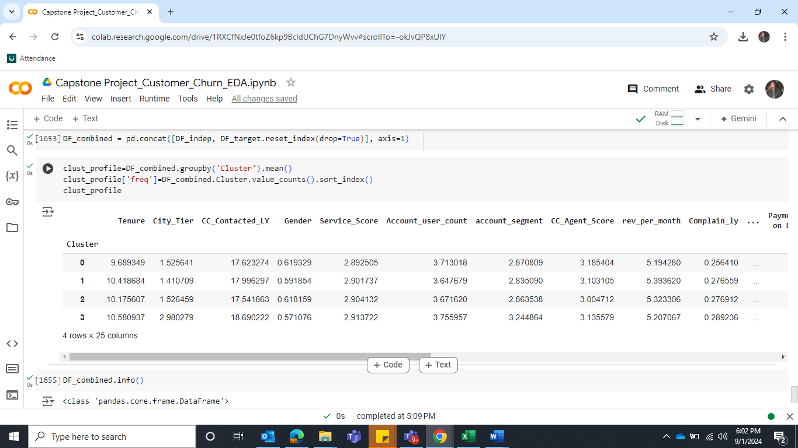

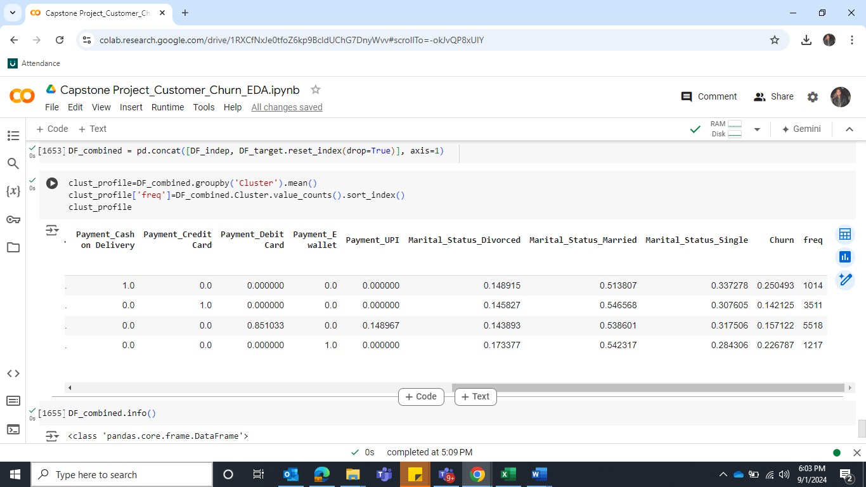

**Table 12: View of dataset after taking mean of all the variables as cluster wise**

**Business Insight from clusters**

Cluster 0 has 1014 accounts frequency where their churn rate is 0.25 and with the following details.

* Tenure: 9.7 months
* City Tier 1 mostly
* Payment method: Cash on delivery
* Revenue per Month: 5.19
* Marital Status: 51% married
* Gender: Male majority

Cluster 1 has 3511 accounts frequency where their churn rate is 0.14.

* Tenure: 10.4 months
* City Tier 1 mostly
* Payment method: Credit card
* Revenue per Month: 5.39
* Marital Status: 54% married
* Gender: Male majority

Cluster 2 has 5518 accounts frequency where their churn rate is 0.15

* Tenure: 10.2 months
* City Tier 1 mostly
* Payment method: Primarily Debit card and some UPI
* Revenue per Month: 5.32
* Marital Status: 53% married
* Gender: Male majority

Cluster 3 has 1217 accounts frequency where their churn rate is 0.22

* Tenure: 10.6 months
* City Tier : 3
* Payment method: E Wallet
* Revenue per Month: 5.20
* Marital Status: 54% married
* Gender: Male majority

1. Cluster 1 and 2 have the lower churn rate and their revenue is also higher than cluster 0 and 3.
2. Cluster 0 is using payment method as Cash on delivery, so they follow traditional payment method. Retention strategies could be focused on offering better online payment options or discount for switching into the digital platform.
3. Cluster 0 has an average tenure of 9.7 months, so it means that they have shorter tenure and higher churn rate. Focus on onboarding and early engagement strategies to solidify their relationship with the company. Personalized communication and first-time discounts or offer can help reduce churn.
4. Cluster 1 has better average tenure as 10.4 with lowest churn rate which indicates that they are most loyal customers to the company. The company should provide them with some reward or loyalty offers for long-term relationships.
5. Cluster 2 has the highest number of customers with second lowest churn rate, their average tenure is also better than cluster 0. The company should focus on this group as well to engage the customers for a long time by providing them loyalty offers or some reward discounts.
6. Cluster 3 has also second highest churn rate after cluster 0, they are using E wallet method for the payment mode, they have the highest average tenure and are from Tier 3 city which indicates that their customers are engaged from a long time but are dissatisfied with either services or geographical restrictions. Company should plan to find their dissatisfaction root cause and mitigate them before they churn as they are long tenure customers. Provide them E wallet top up offers.

**Model building - Clear on why was a particular model(s) chosen. - Effort to improve model performance.**

Since the dataset is imbalanced as the proportion of churned customers (1's) is significantly lower than non-churned customers (0's), the data is considered unbalanced. To deal with unbalanced data, we are applying SMOTE (Synthetic Minority Over-sampling Technique).

SMOTE works by generating synthetic samples by interpolating between existing minority class samples. It calculates the Euclidean distance between points in the feature space to create new points along the lines connecting nearest neighbors.

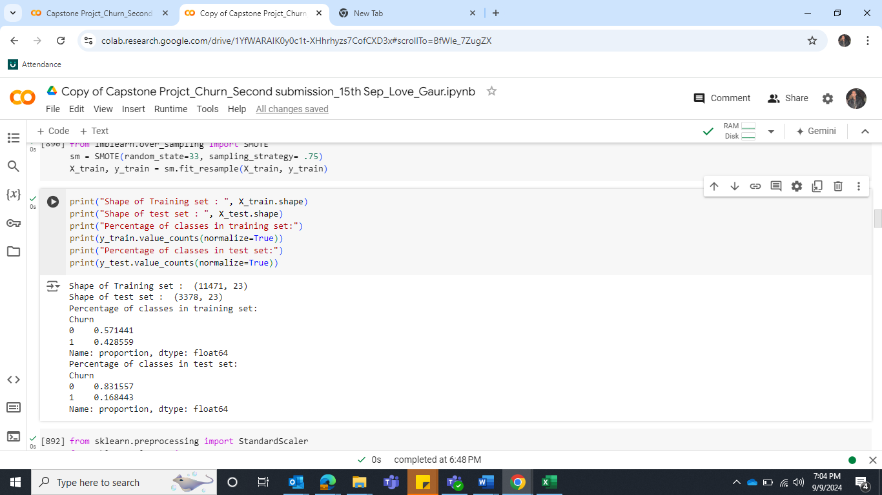

**Table 13: Shape of training and test set after SMOTE**

**Scale the data with the help of StandardScaler from sklearn**

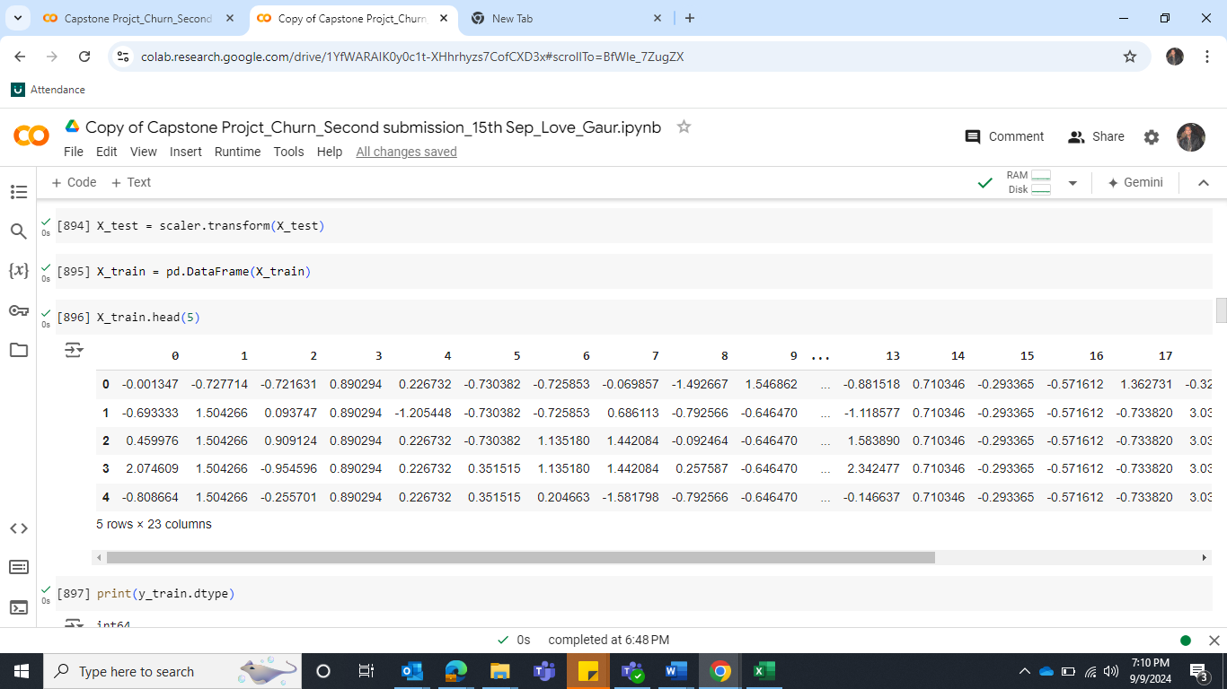

**Table 14: Top 5 rows of data after Scale**

**Model Building:**

Since this is a binary classification problem we will create the following models.

**1 - Logistic Regression Model**

Let’s import LogisticRegression from Sklearn linear model, define the model with the following Parameters

solver='newton-cg', max_iter=10000,penalty='none',verbose=True,n_jobs=2

Fit the model on train dataset

**AUC and ROC for the training data**

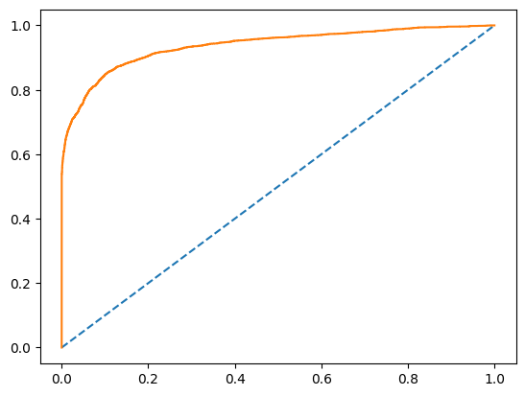 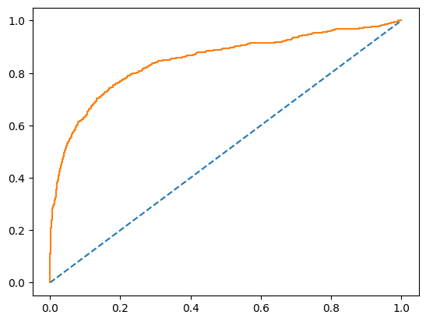

**Figure 45: AUC and ROC for the training data Figure 46: AUC and ROC for the test data**

**Train: AUC: 0.937 and Test: AUC: AUC: 0.937**

**Confusion Matrix and Classification report for the training data and Test data**

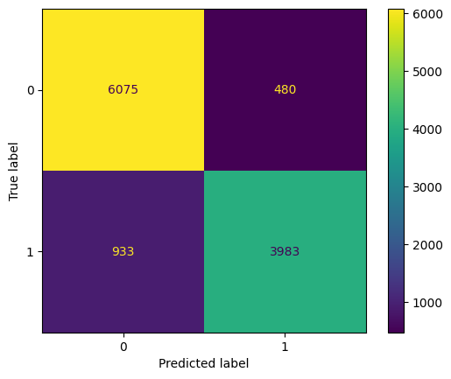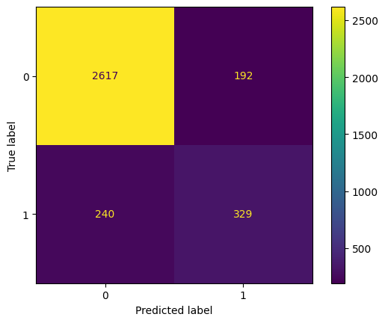

**Figure 47: Confusion Matrix for the training data Figure 48: Confusion Matrix for the Test data**

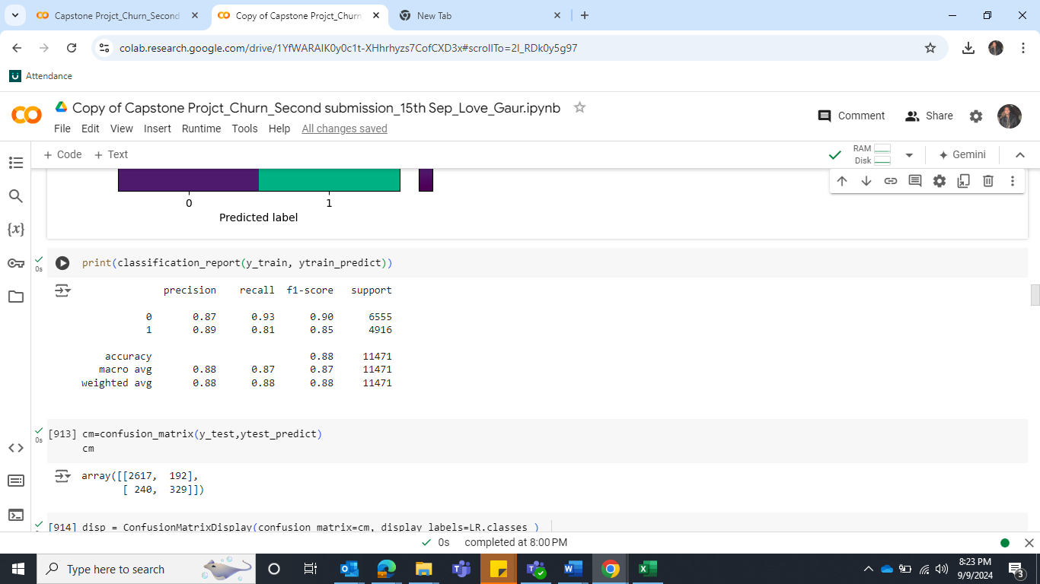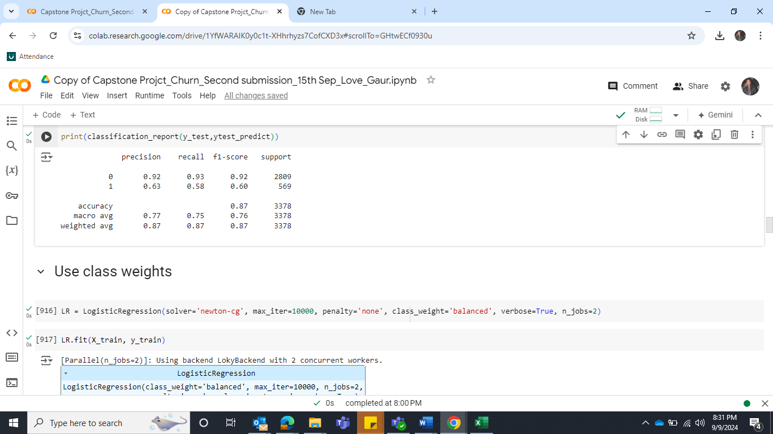

**Table 15: Classification Report for the training and test data**

**Insight**

**Accuracy:** Training Accuracy: 0.88 and Test Accuracy: 0.87

The Logistic regression model achieves relatively similar accuracies on both the training and test

Datasets.

**Recall of class "1":**

Training Recall of 1’s: 0.81 and Test Recall of 1’s: 0.58

The recall of class "1" represents the ability of the model to correctly identify instances belonging

to class "1" (e.g., churn). The recall value of train is good, but it drops in test dataset, indicating that

the model is overfitting.

**Precision of class "1":**

Training Recall of 1’s: 0.89 and Test Recall of 1’s: 0.63

All the instances predicted as class 1, 89% were correct but it drops in test dataset to 63%. It suggests that the model is making more incorrect predictions for class 1 in the test set, resulting in a higher false positive rate for this class.

**F1-score of class “1”:**

Training F1-score of 1’s: 0.85 and Test F1-score of 1’s: 0.60

The harmonic mean of precision and recall is good in train dataset but drops in test dataset.

**Area Under the ROC Curve (AUC):**

Training AUC: 0.937 and Test AUC: 0.937

The AUC metric represents the model's ability to discriminate between positive and negative

instances. An AUC value closer to 1 indicates better performance. The Linear regression model

achieves reasonable AUC scores on both training and test datasets, suggesting that it performs

reasonably well in distinguishing between positive and negative instances.

**Hyper Tune the model**

We will tune the model with GridSearchCV. Below are the parameters.

param_grid = { 'C': [0.01, 0.1, 1, 10],  'solver': ['lbfgs', 'liblinear', 'saga'],'penalty': ['l2'], 'class_weight': [None, 'balanced'], 'max_iter': [1000] }

Get the best parameters and the corresponding model on train and evaluate model on Test

dataset.

Best Parameters: LogisticRegression(C=10, class_weight='balanced', max_iter=1000)

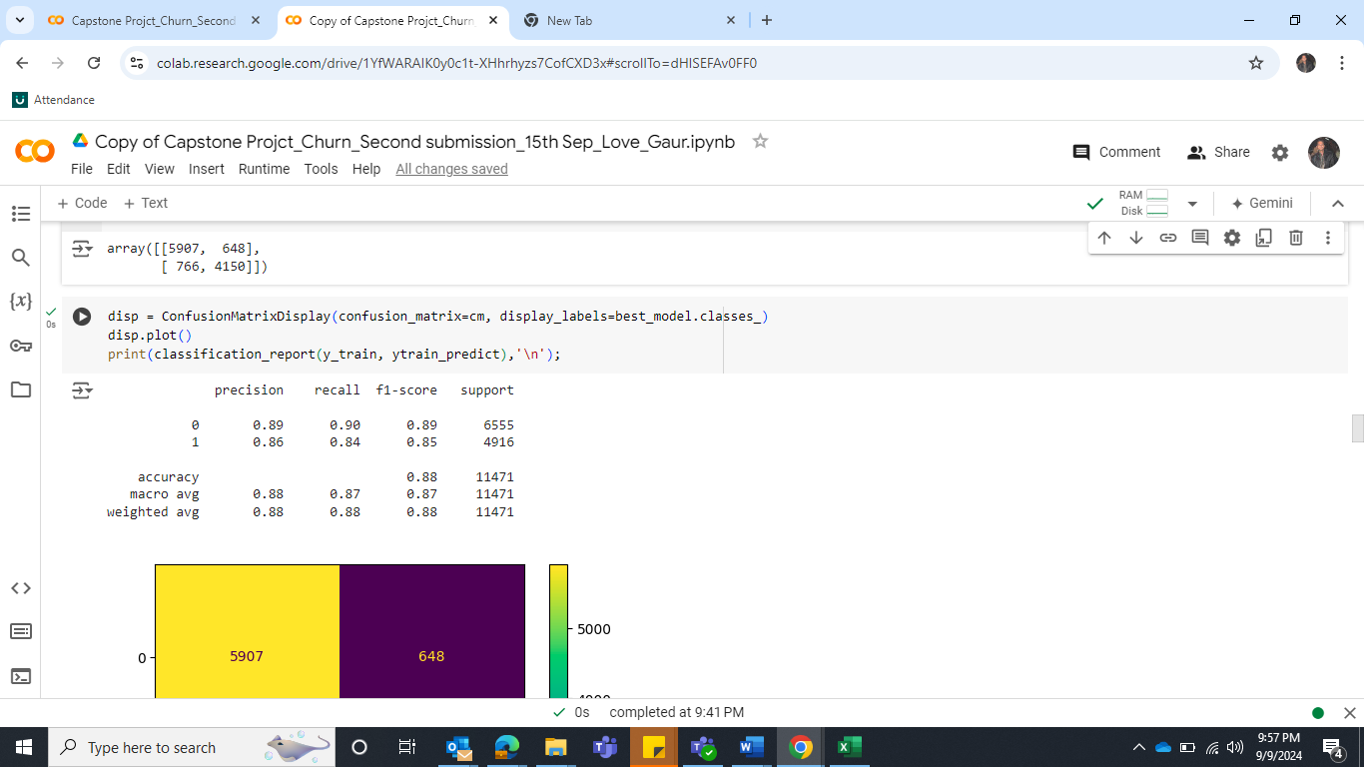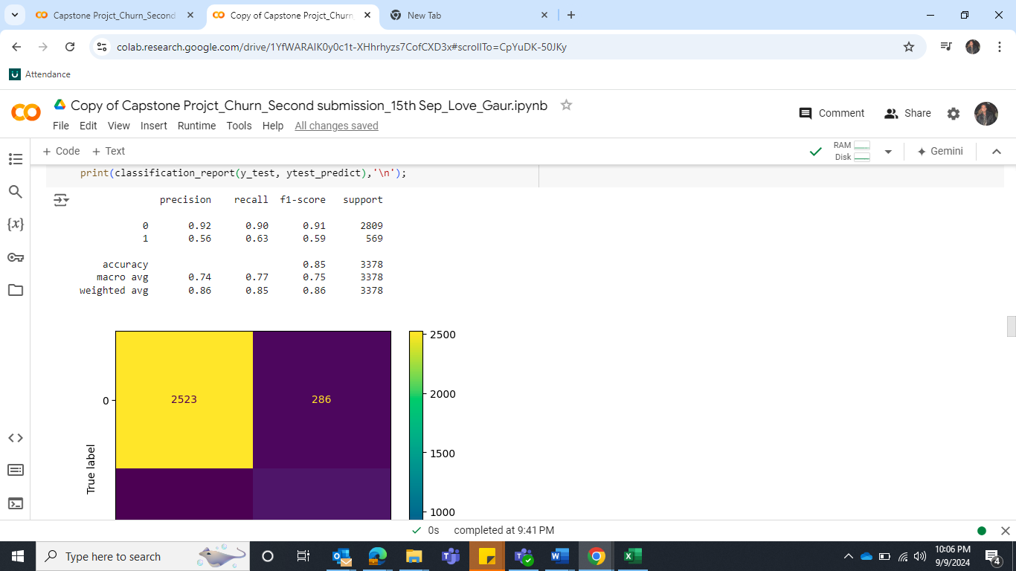

**Table 16: Classification Report for the train data after HyperTune**

**Insight**

**2 - Gaussian Naive Bayes**

Let’s import GaussianNB, define the model and fit the train dataset.

**Confusion Matrix and Classification report for the Train data and Test data**

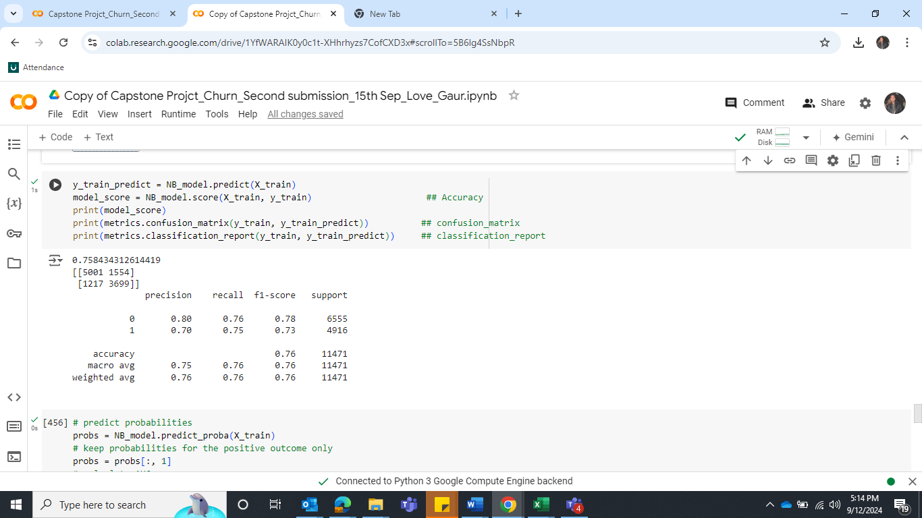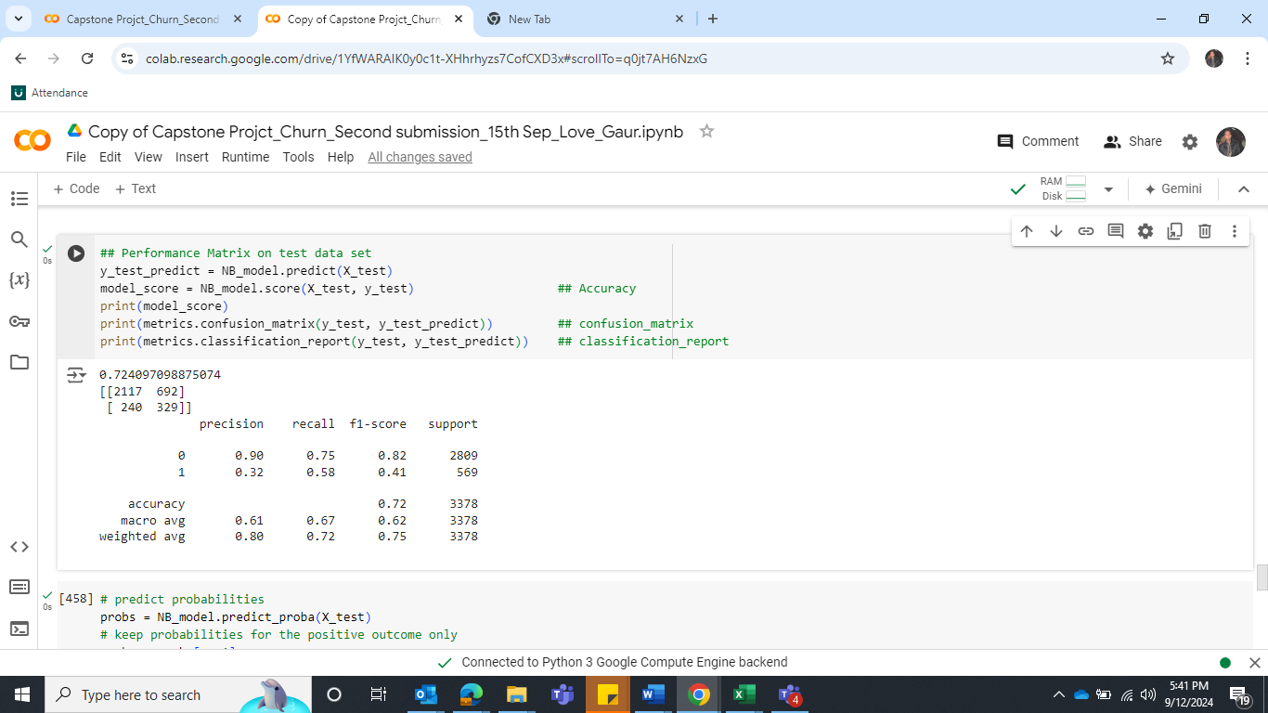

**Table 17: Confusion Matrix and Classification Report for the train and test data**

**AUC and ROC for the train and test data**

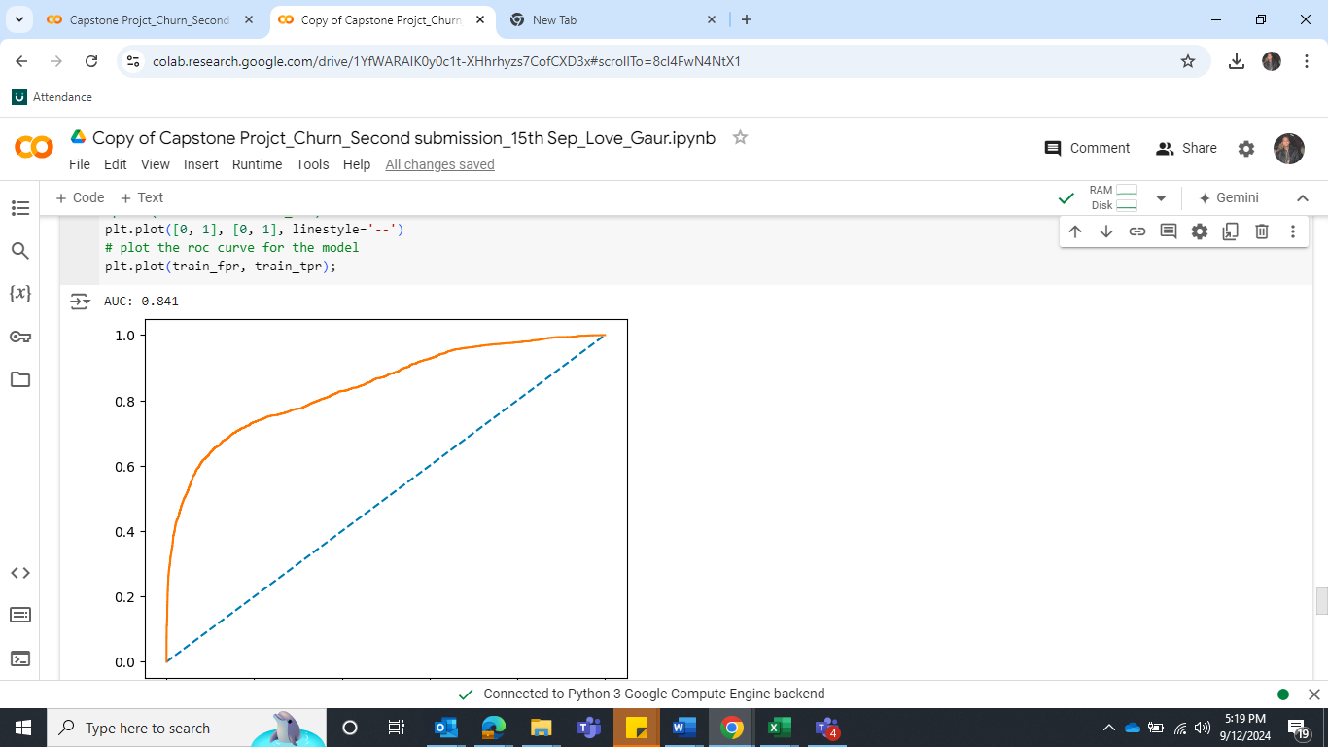 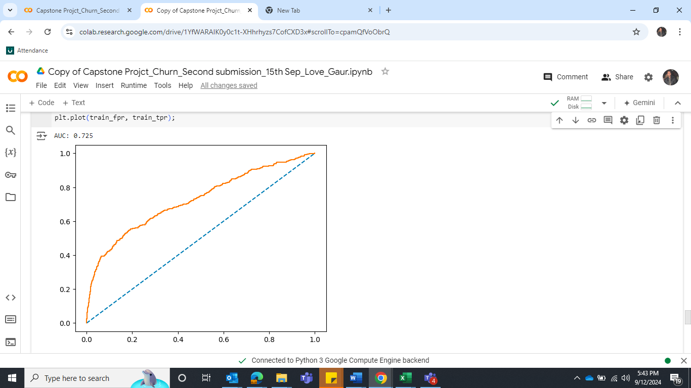

**Figure 49: ROC for the Train data Figure 50: ROC for the Test data**

**Insight -** The model is performed moderately on train dataset; the recall value looks similar for class 0 and 1. But the precision value of class 0 is higher than class 1. However, model performance decreased on unseen data as precision and recall values of class 1 are 0.32 and 0.58.

**HyperTunning the Model**

We will tune the model with GridSearchCV. Below are the parameters.

param_grid = {'var_smoothing': [1e-9, 1e-8, 1e-7, 1e-6]}

**Best parameters: {'var_smoothing': 1e-09}**

Let’s fit the model and predict the model

**Confusion Matrix and Classification report for the train and test data**

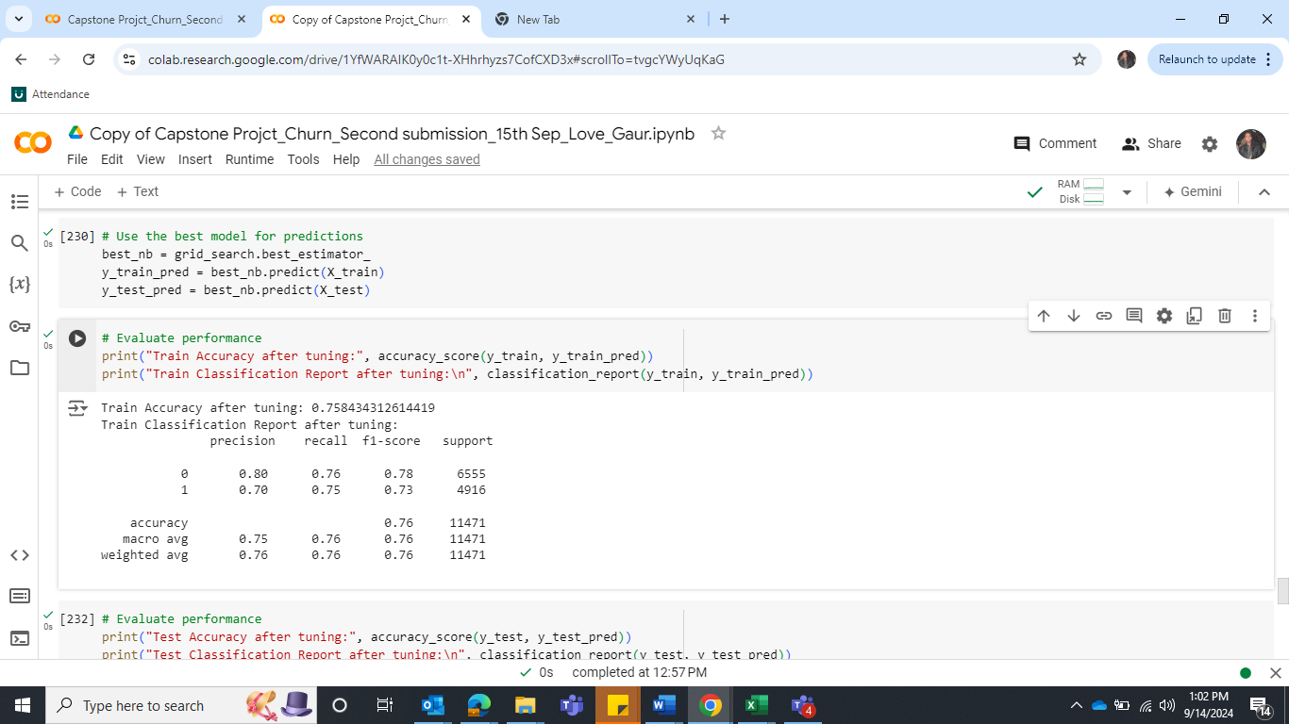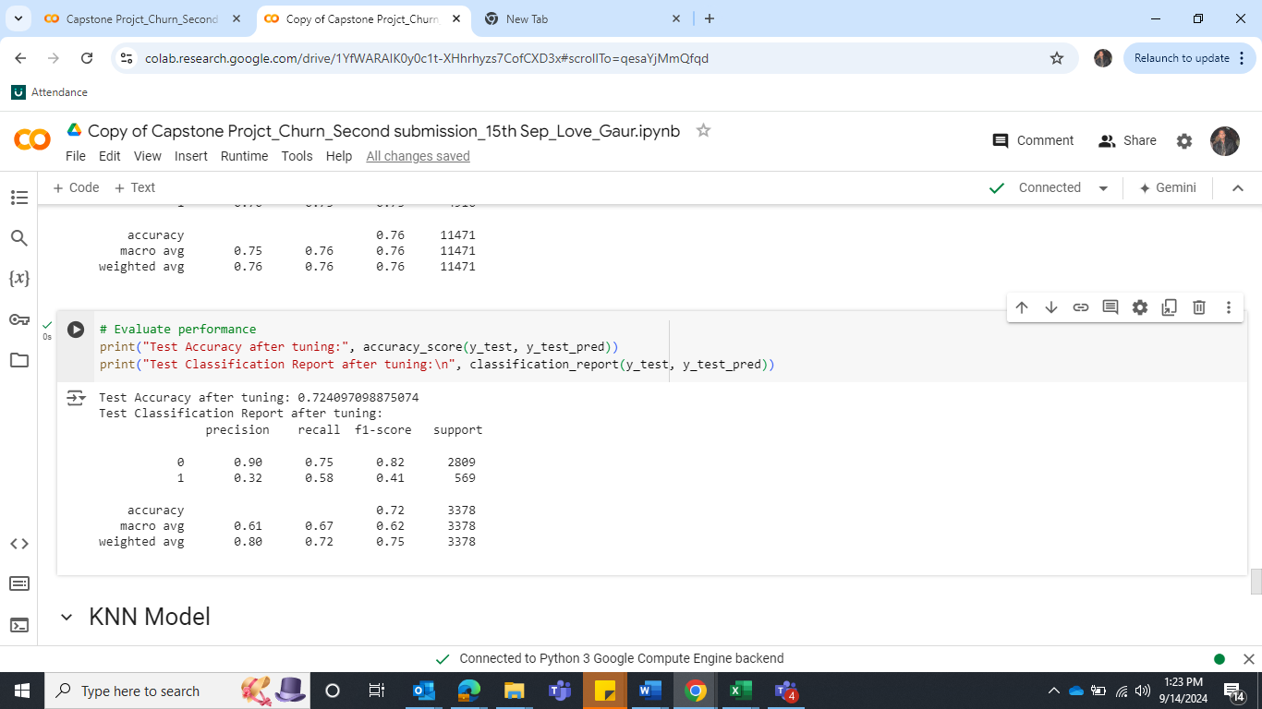

**Table 18: Classification Report for the train data Table 19: Classification Report for the test data**

**Insight**

After hyper tunning, there is no sign of Improvement. The result remains the same. Let’s build another model.

**3 - KNN Model**

Let’s import KNeighborsClassifier, define the model and fit the train and test dataset.

**AUC and ROC for the train data**

ROC AUC Train: 0.9985654805460958 and Test: ROC AUC: 0.9707740184856484

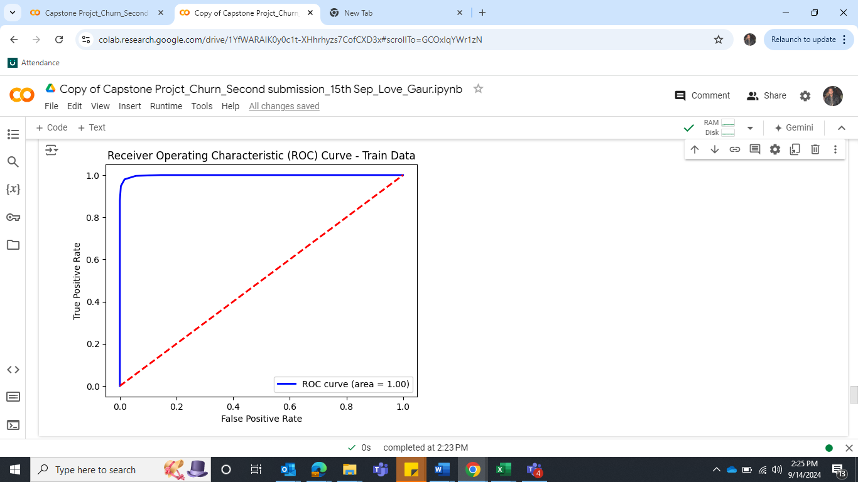 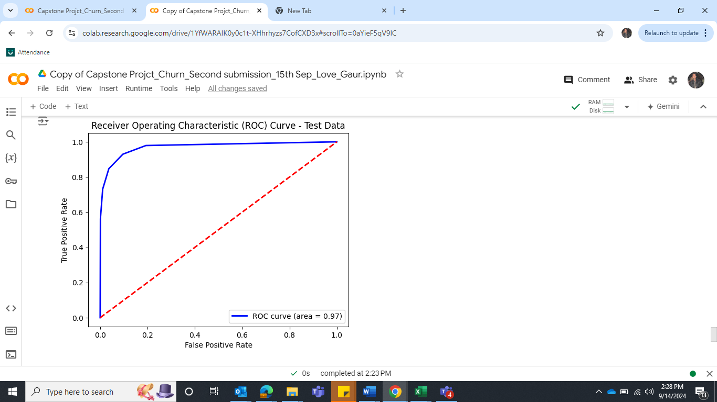

**Figure 51: ROC for the Train data Figure 52: ROC for the Train data**

**Confusion Matrix and Classification report for the train and test data**

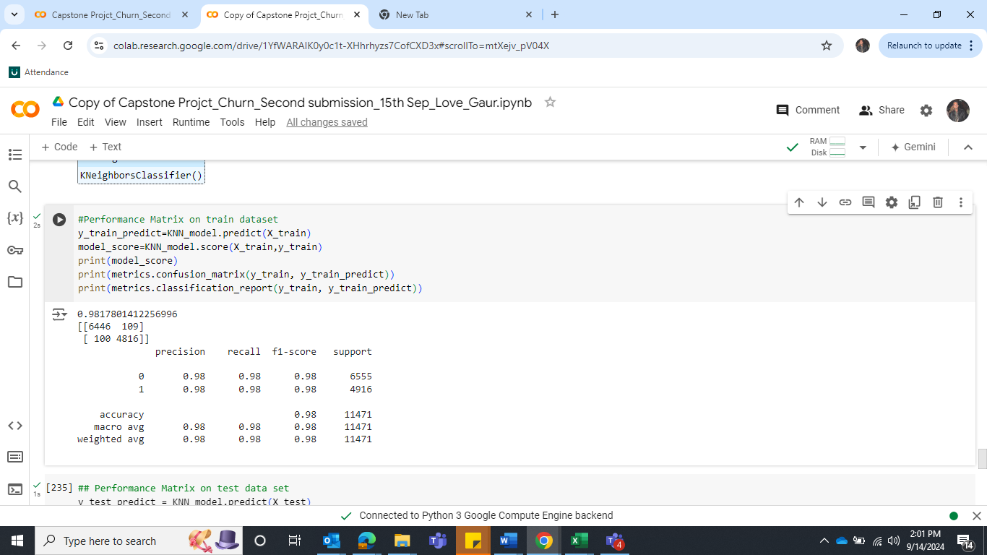 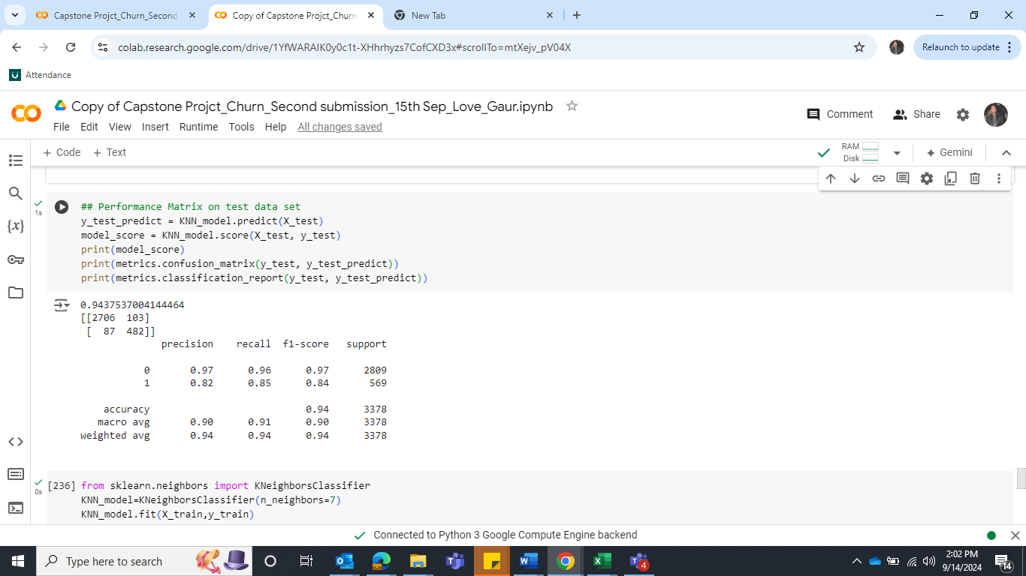

**Table 20: Classification Report for the train data Table 21: Classification Report for the test data**

**Insight**

There’s a slight drop in performance between the training and test sets, particularly in recall, precision, and F1 score. This indicates minor overfitting. Next step is Cross-Validation, can provide better insight into model stability across different data splits.

**Cross-Validation**

Let’s compute cross-validation scores for a KNN model.

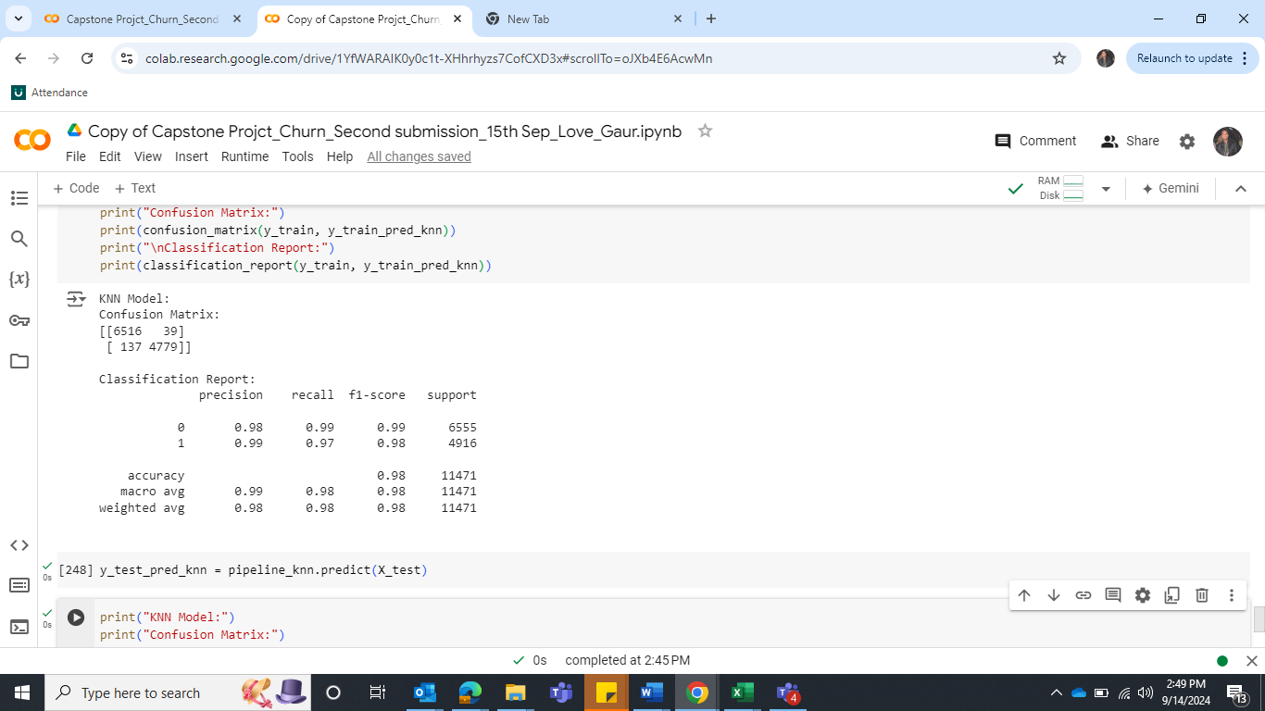 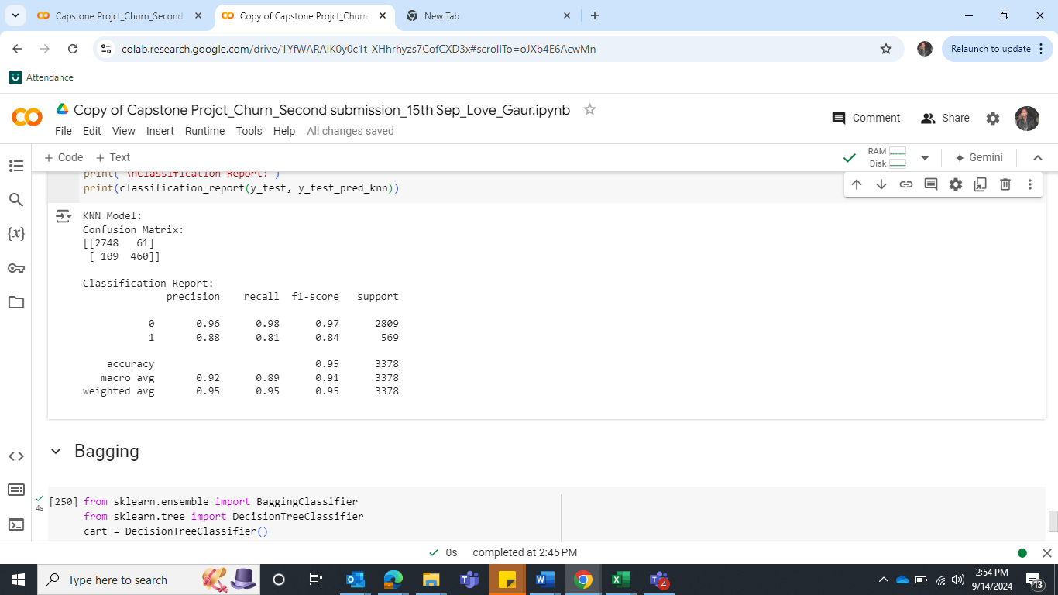

**Table 22: Classification Report for the train data Table 23: Classification Report for the test data**

**Insight**

After hyperparameter tuning, the model exhibits improved **precision** and **F1-score** for the test set, even though there is a small trade-off in **recall**. The accuracy is also slightly better, making the hypertuned model more reliable overall, especially in terms of reducing false positives.

**4 - Random Forest Model**

Let’s import RandomForestClassifier, define the model and fit the train dataset.

**Confusion Matrix and Classification report for the train and test data**

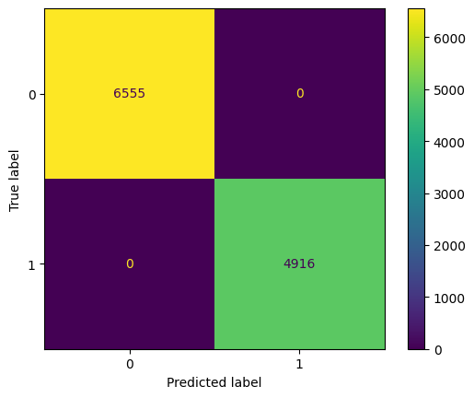 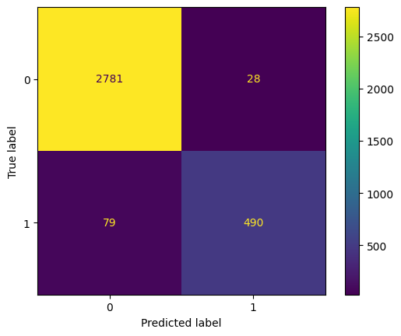

**Figure 53: Confusion Matrix for the Train data Figure 54: Confusion Matrix for the Test data**

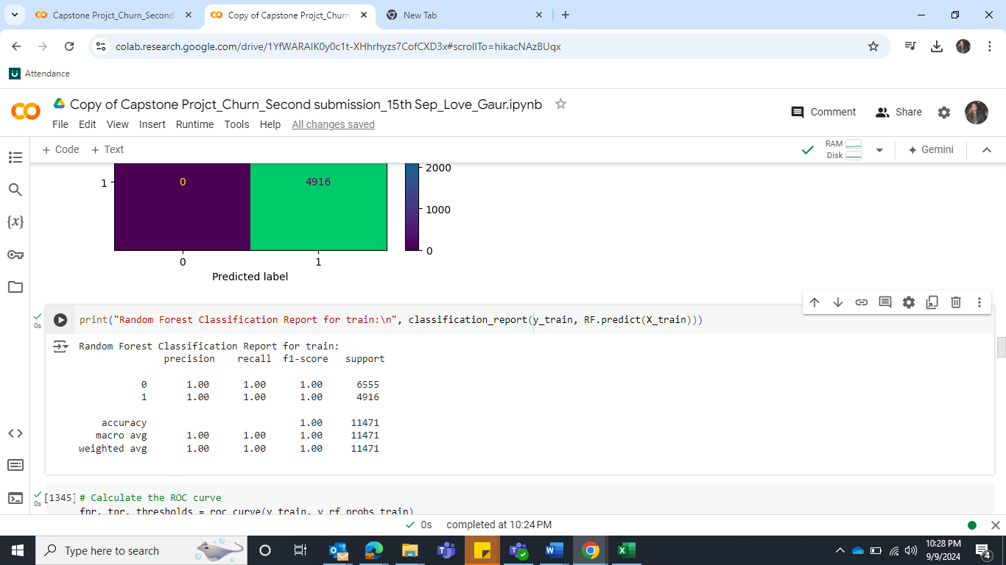 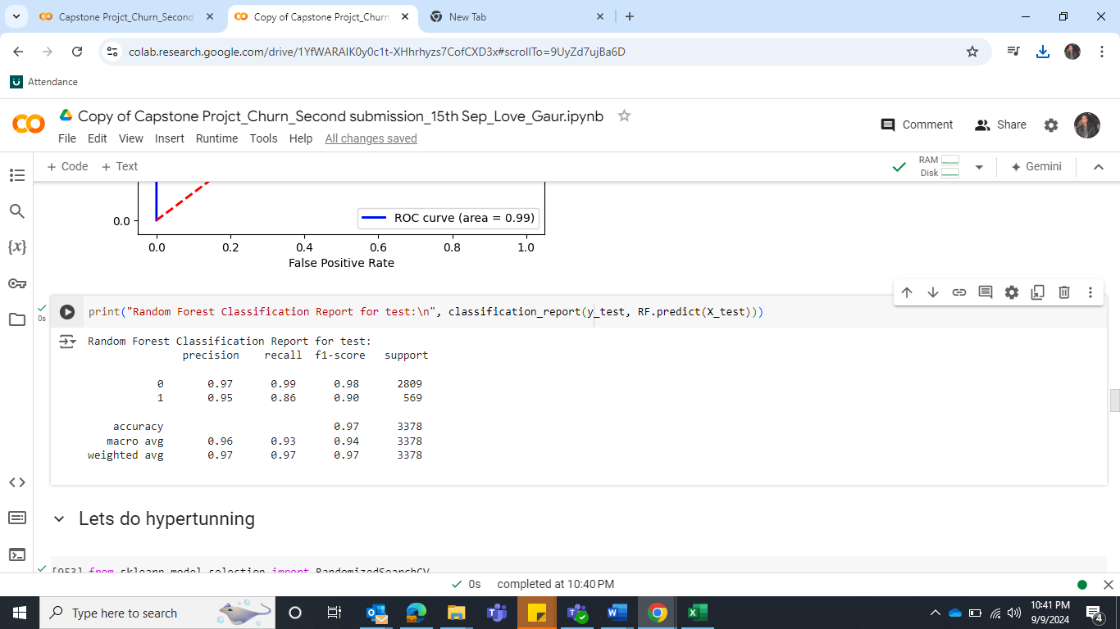

**Table 24: Classification Report for the train data Table 25: Classification Report for the test data**

**AUC and ROC for the train and test data**

Train: ROC AUC: 1.0 and Test: ROC AUC: 0.988

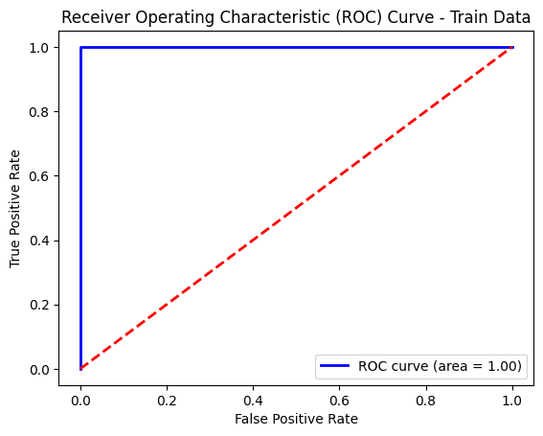 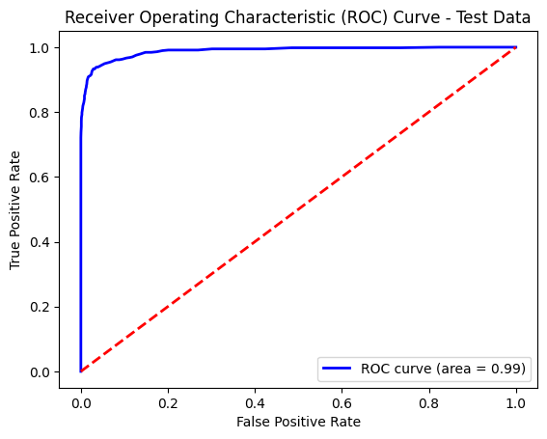

**Figure 55: ROC AUC for the Train data Figure 56: ROC AUC for the Train data**

**Insight**

**Accuracy:** Training Accuracy: 1.00 and Test Accuracy: 0.97

Random forest model achieves extremely good accuracy on the train dataset, But it drops slightly on the test dataset.

**Recall of class "1":**

Training Recall of 1’s: 1.00 and Test Recall of 1’s: 0.86

The recall of class "1" represents the ability of the model to correctly identify instances belonging

to class "1" (e.g., churn). The recall value of train is good, but it drops in test dataset, indicating that

the model is overfitting.

**Precision of class "1":**

Training Recall of 1’s: 1.00 and Test Recall of 1’s: 0.95

All the instances predicted as class 1, 100% were correct but it drops in test dataset to 95%. It suggests that the model is making more incorrect predictions for class 1 in the test set, resulting in a high false positive rate for this class.

**F1-score of class “1”:**

Training F1-score of 1’s: 1.00 and Test F1-score of 1’s: 0.86

The harmonic mean of precision and recall is good in train dataset but drops in test dataset.

**Area Under the ROC Curve (AUC):**

Training AUC: 1.00 and Test AUC: 0.98

The AUC metric represents the model's ability to discriminate between positive and negative

instances. AUC 1 in the train dataset indicates that the model is perfectly separating the classes during training. AUC 0.98 in test suggesting strong discrimination capability on the test set.

This performance difference (perfect training but slightly lower test performance) suggests that your model might be overfitting.

**Hyper Tune the model**

We will tune the model with RandomizedSearchCV. Below are the parameters.

param_dist = {'n_estimators': randint(100, 500),  'max_depth': randint(5, 15), 'min_samples_split': randint(2, 10), 'min_samples_leaf': randint(1, 10),

'max_features': ['auto', 'sqrt'], 'class_weight': [None, 'balanced']}

Here are the best parameters –

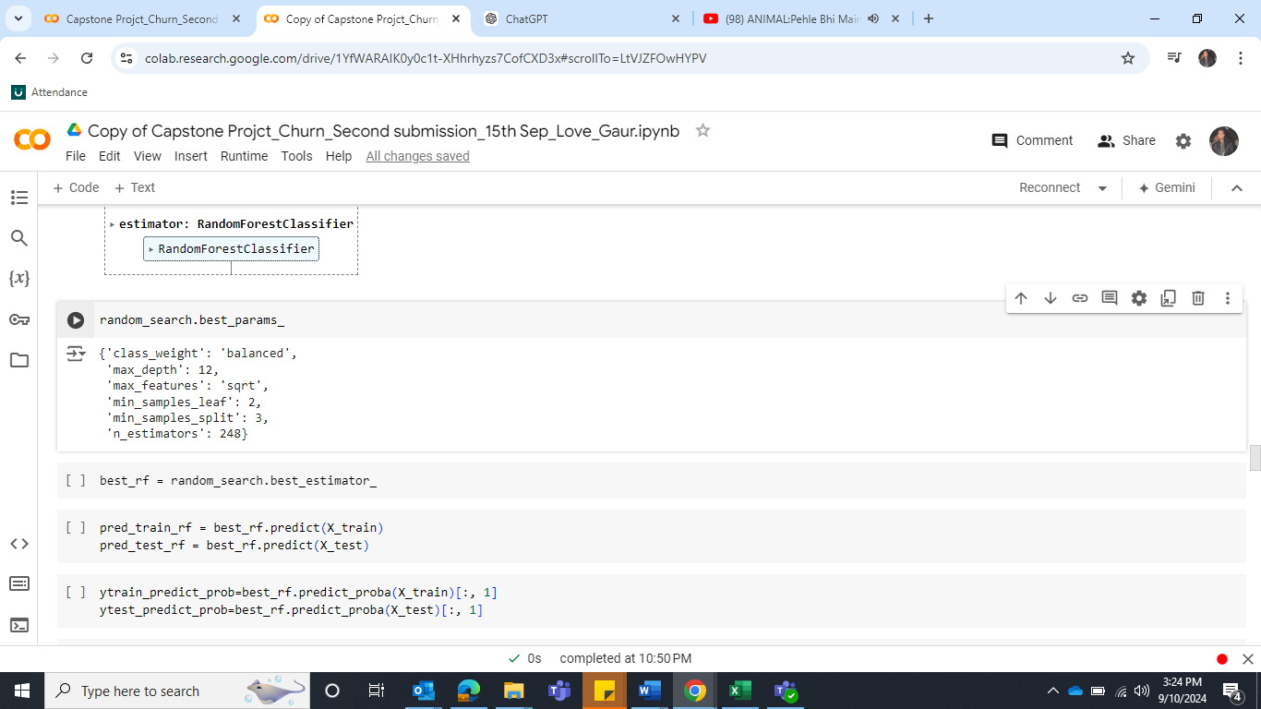

Fit the model and predict the train and test.

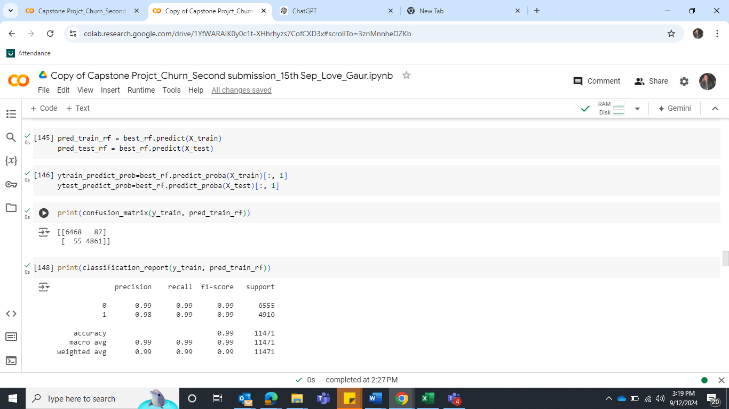 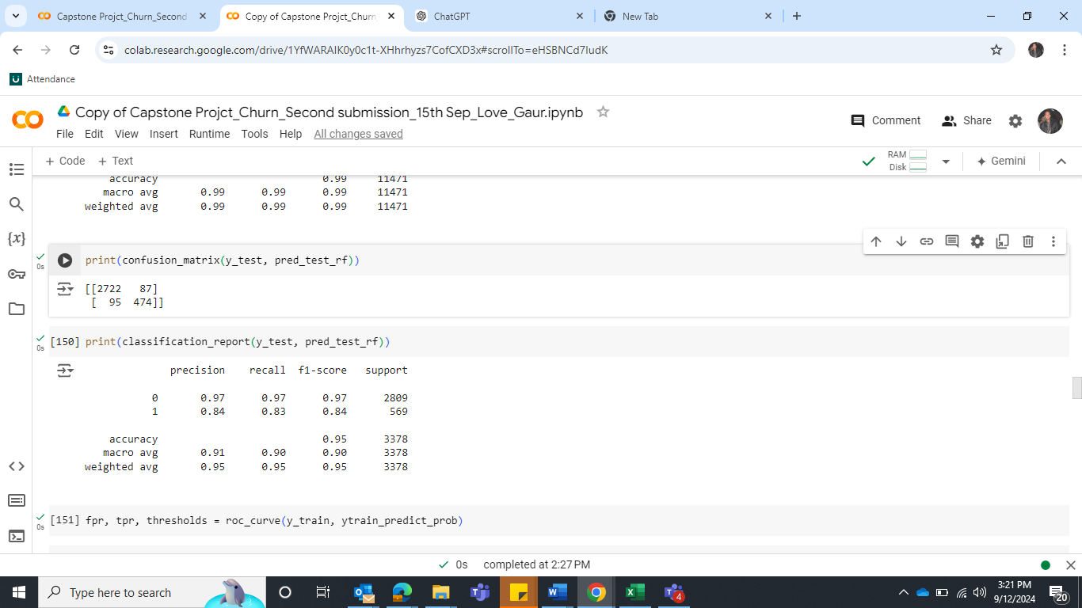

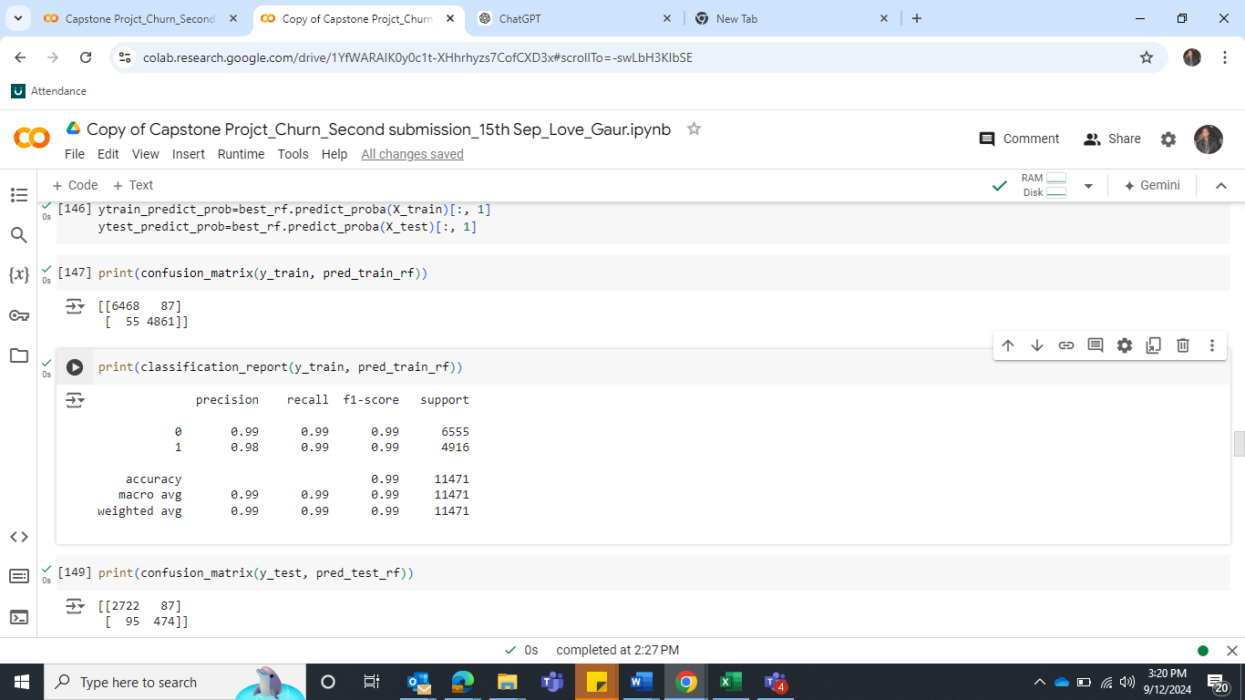 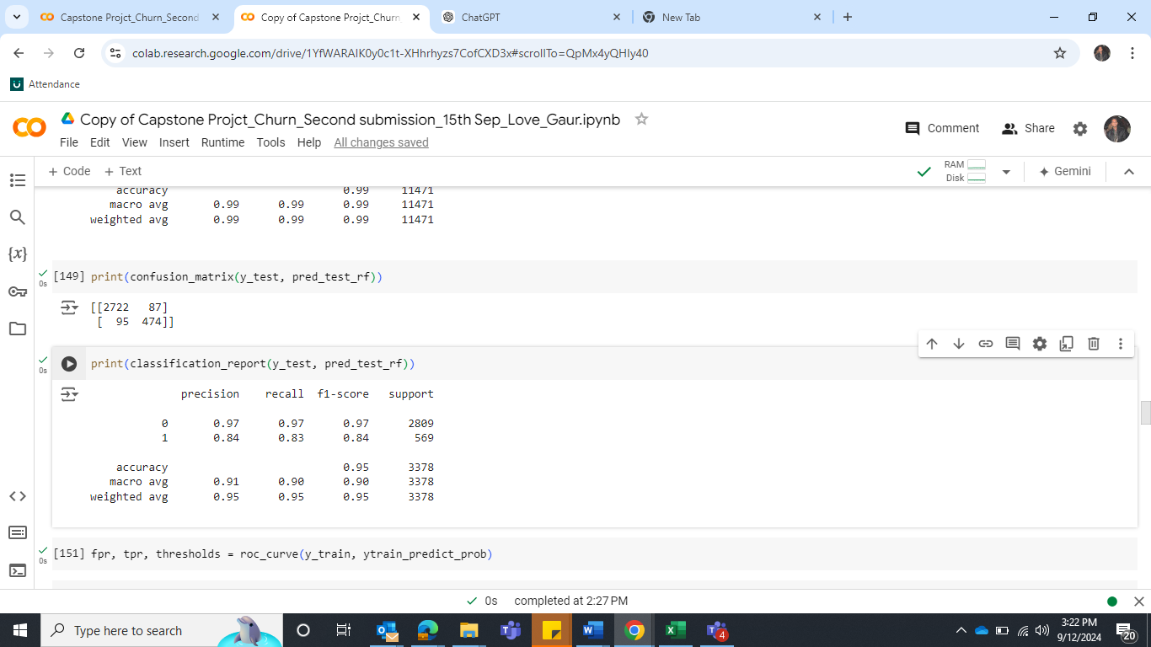

**Table 26: Confusion and Classification Report of train data Table 27: Confusion and Classification Report of test data**

**Insight**

After tuning, the model's performance on the training set was slightly reduced to more realistic values (precision and recall ~0.99), suggesting reduced overfitting. However, in the test set, performance for class 1 dropped further, with precision and recall around **0.84** and **0.83**, respectively. This indicates the model may still be struggling to capture all instances of class 1 in the test set.

**Let’s try to change the threshold value**

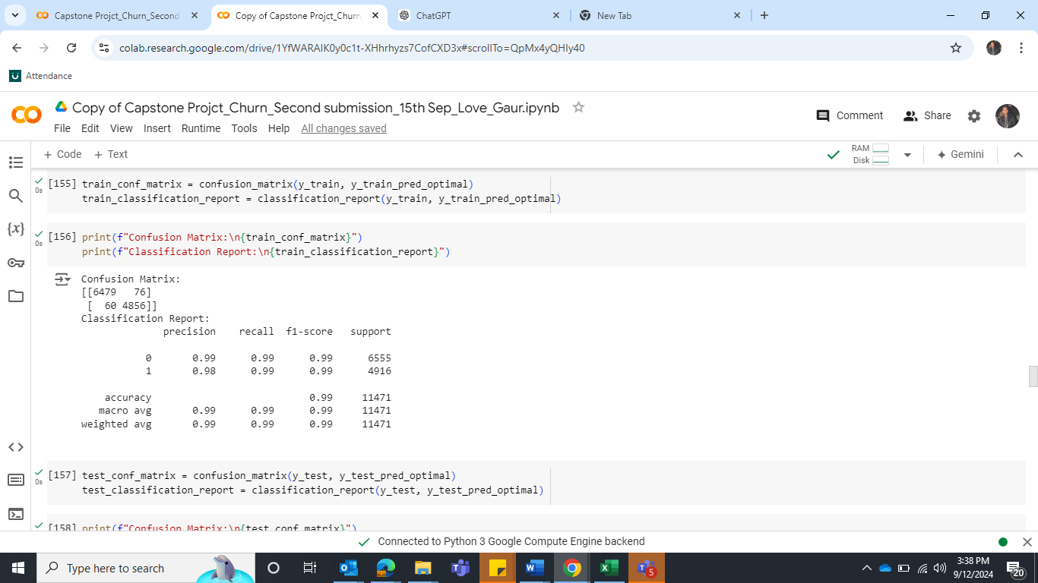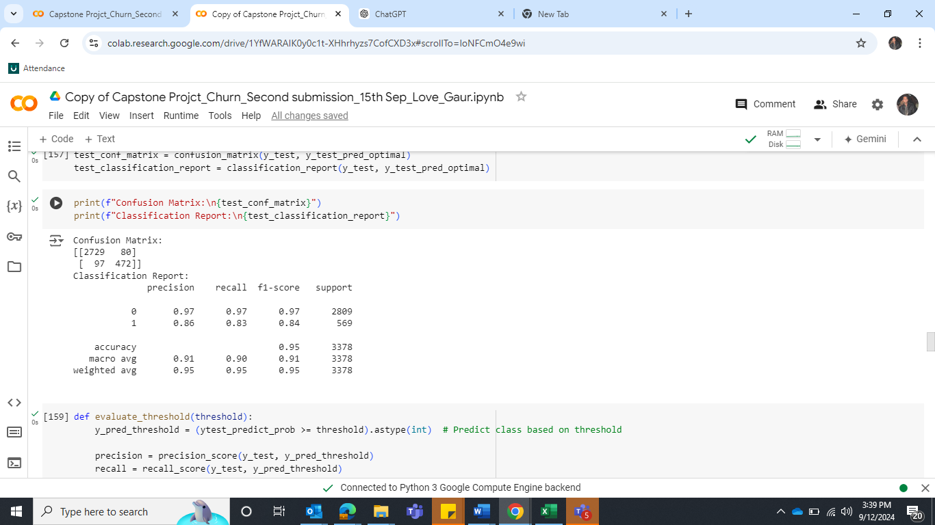

**Table 28: Classification Report of train data Table 29: Classification Report of test data**

**Insight**

The model's performance on the training set was slightly reduced to more realistic values (precision 0.98 and recall 0.99), suggesting reduced overfitting. However, in the test set, performance for class 1 dropped further, with precision and recall around **0.86** and **0.83**, respectively. This indicates the model may still be struggling to capture all instances of class 1 in the test set.

**Model 5 - Boosting**

Let’s build another model ***Ada Boost.***

Import the model, define the model and fit the model.

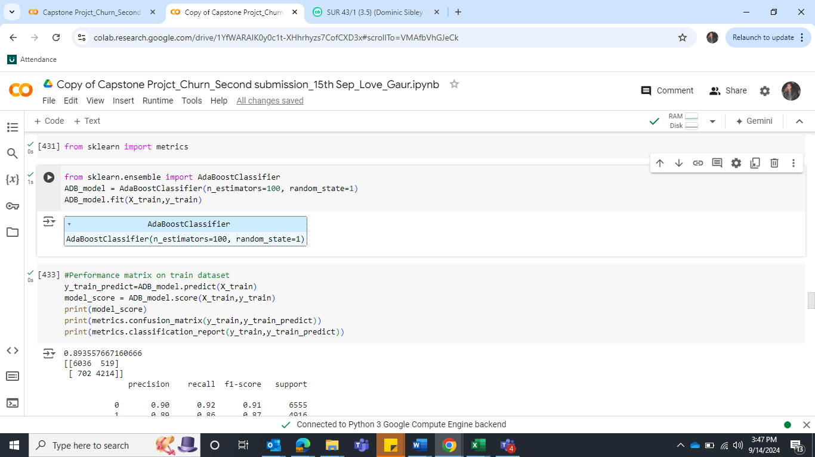

**Confusion Matrix and Classification report for the train and test data**

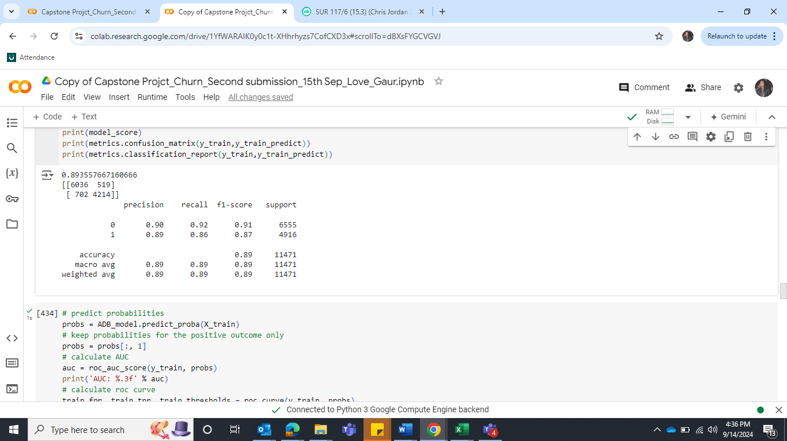 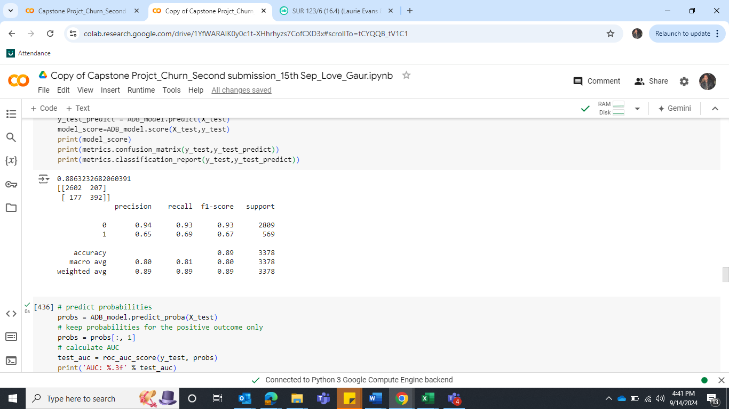**Table 30: Confusion & Classification Report of train data Table 31: Confusion & Classification Report of test data**

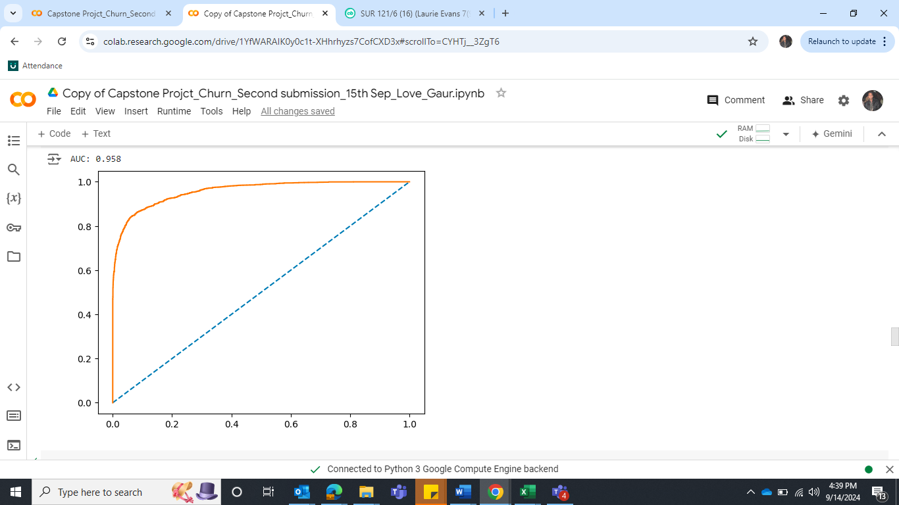 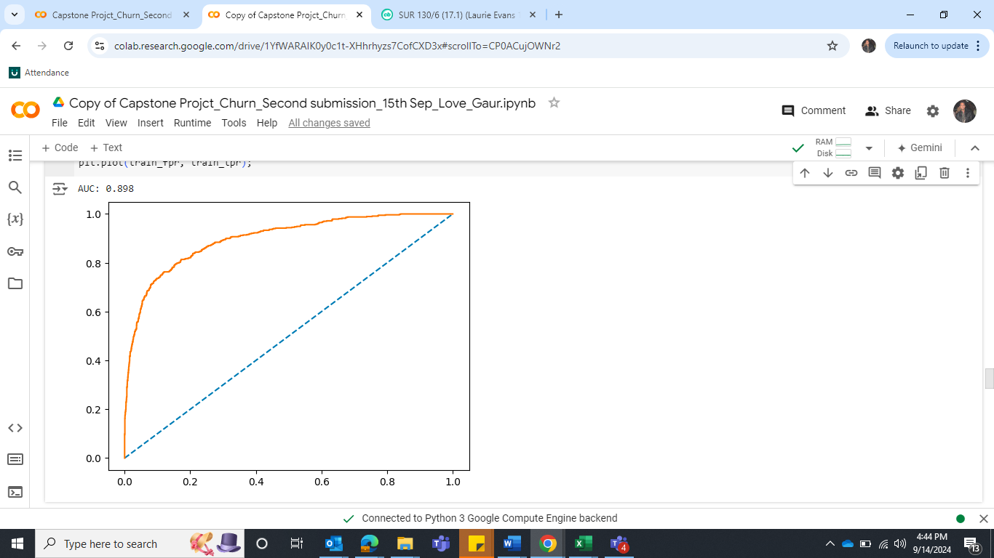

**Figure 57: ROC Map for the Train data Figure 58: ROC Map for the Test data**

**Insight**

This model is also performing good in train data as accuracy is 89, Recall and Precision value is also good such as 86 and 89. However, their values dropped in test dataset as 69 and 65. This model still needs to improve with hyper tunning.

**Hyper Tune the model**

We will tune the model with DecisionTreeClassifier. Below are the parameters.

base_estimator = DecisionTreeClassifier(max_depth=2, class_weight={0: 1, 1: 5})

**Confusion Matrix and Classification report for the train and test data**

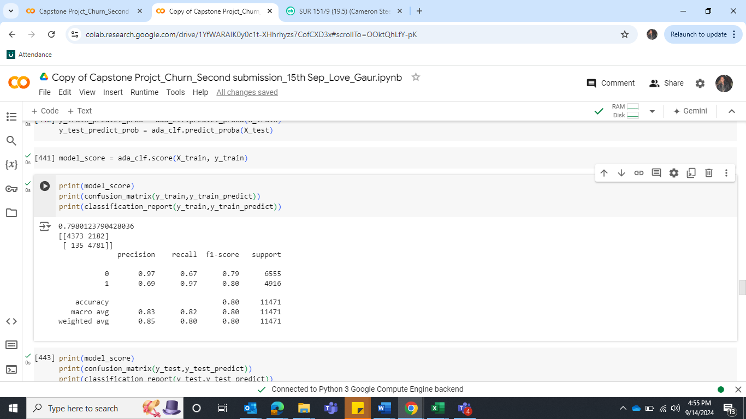 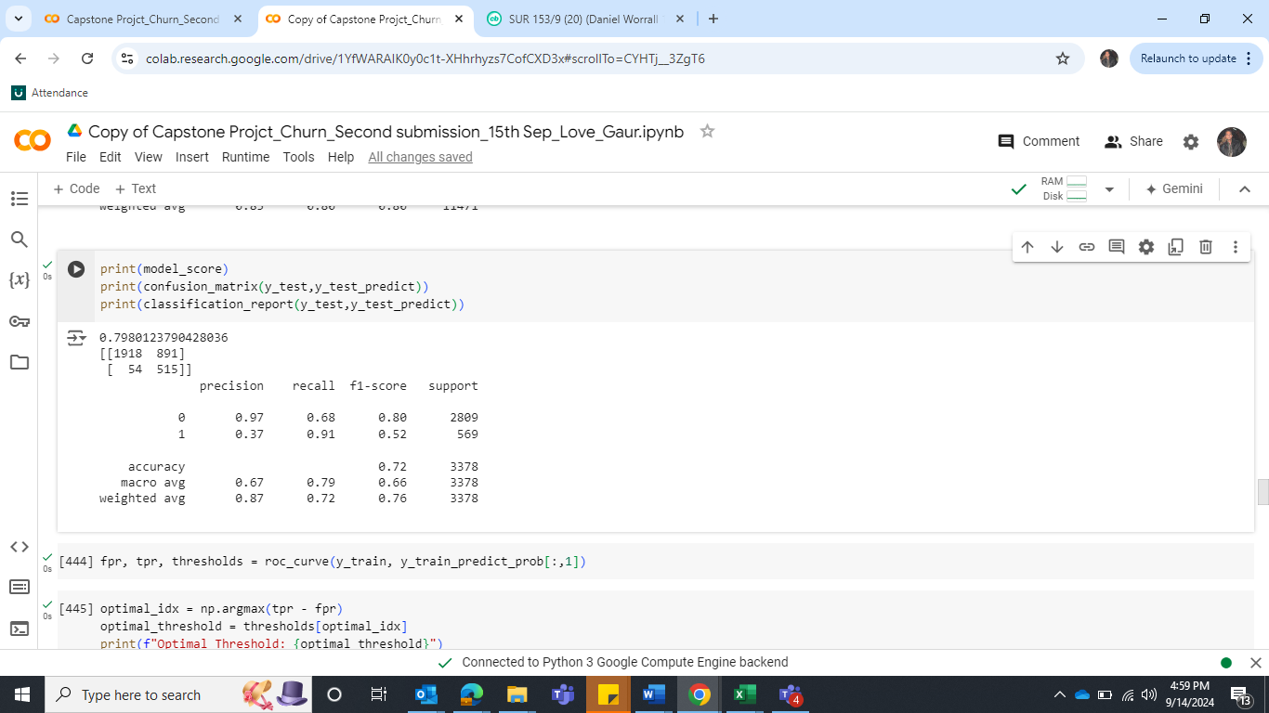

**Table 32: Confusion matrix and Classification Report of train and Test data**

**Insight**

1. Recall (Test) improved significantly after hyperparameter tuning (from 0.69 to 0.91), which suggests the model became much better at identifying positive cases (class 1).
2. Precision (Test) however, dropped substantially after tuning (from 0.65 to 0.37). This could indicate the model is now classifying more false positives.
3. F1 Score (Test) improved slightly (from 0.67 to 0.72), which is a positive sign as it balances both precision and recall.
4. Accuracy (Test) decreased after tuning (from 0.89 to 0.72), indicating that while recall has improved, the overall classification accuracy has dropped.

After hyperparameter tuning, the model seems to focus more on **recall** at the cost of **precision**, indicating that it's better at identifying positive cases but at the cost of misclassifying negative ones.

Let’s find the optimal threshold value. **Changing the threshold value**

**Confusion Matrix and Classification report for the train and test data**

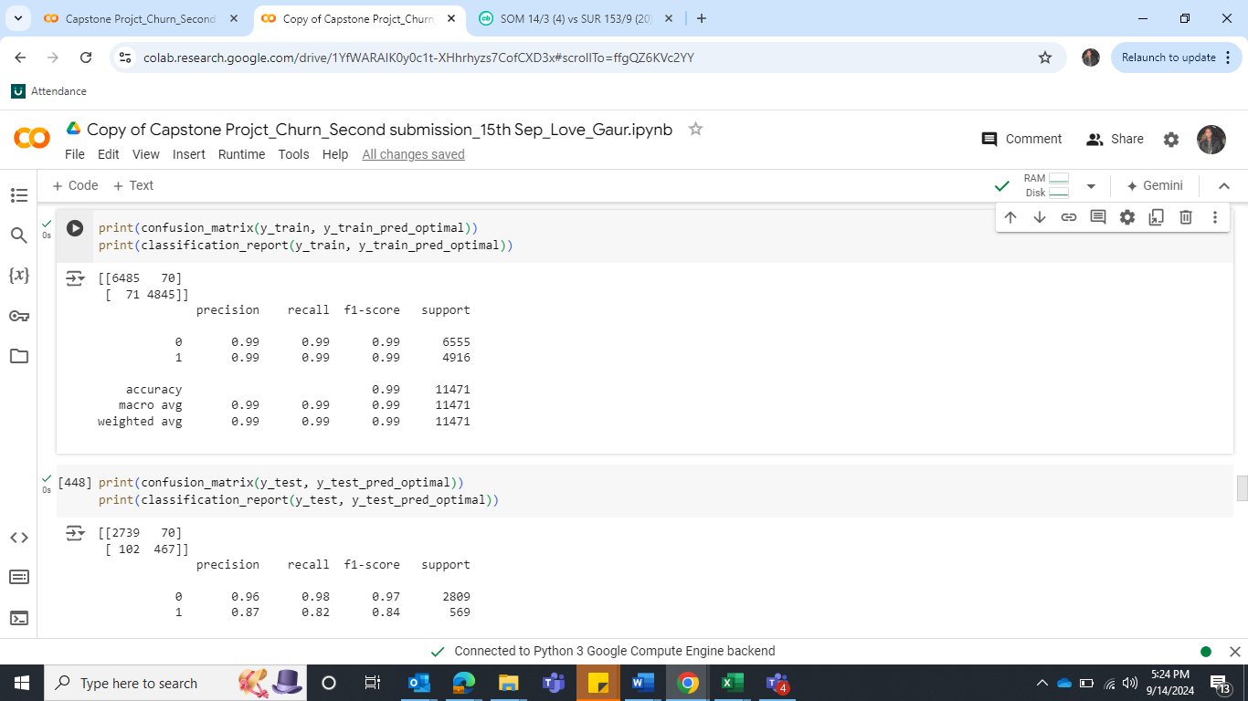 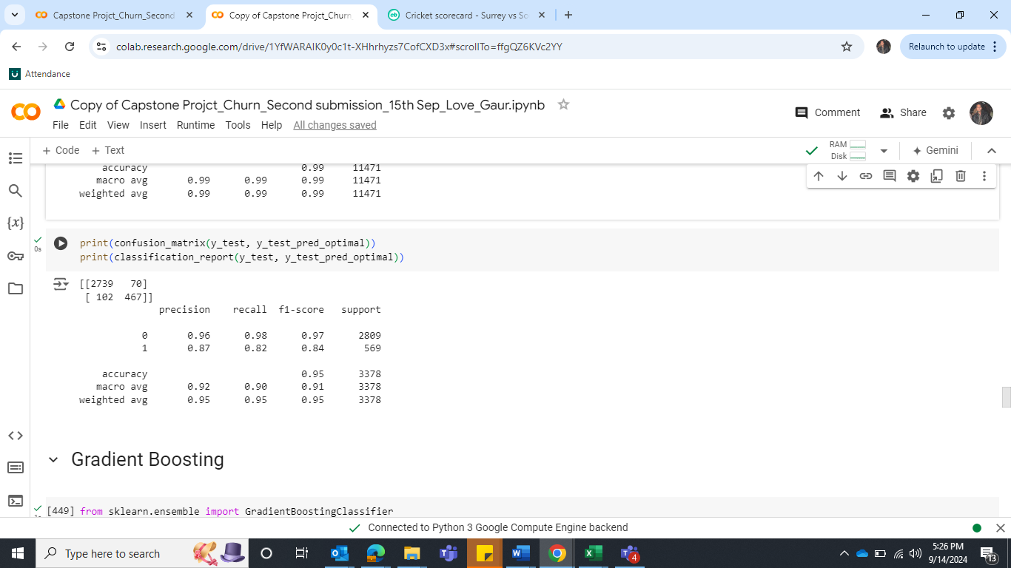

**Table 33: Confusion matrix and Classification Report of train and Test data**

**Insight**

After threshold tuning, the model has shown significant improvement in both train and test performance. After threshold tuning, the model has shown significant improvement in both train and test performance. Recall on the test set decreased slightly from 0.91 to 0.82, but this is a reasonable trade-off for improved precision. Let’s build another model

**Model 6 – Gradient Boosting**

Import the model, define the model and fit the model.

**Confusion Matrix and Classification report for the train and test data**

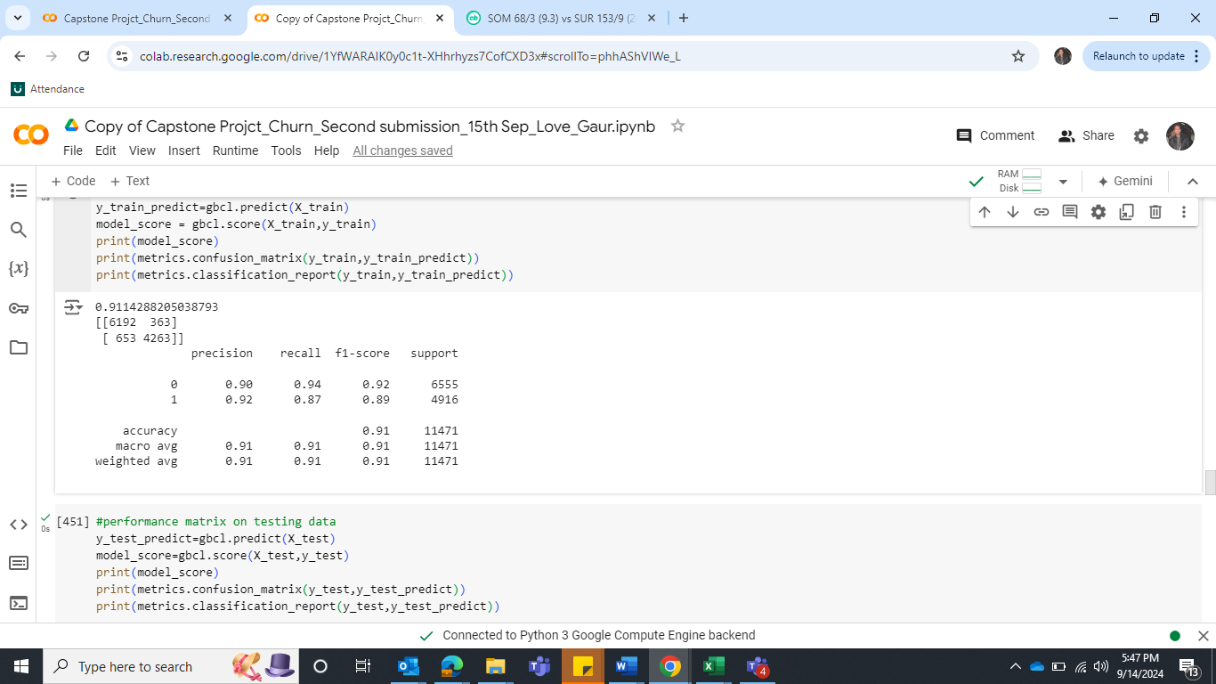 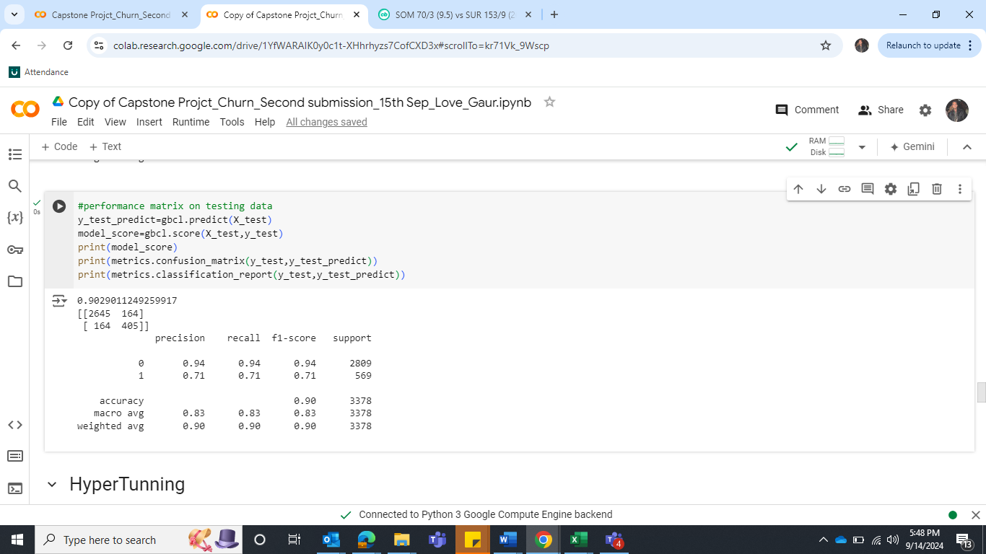

**Table 34: Confusion matrix and Classification Report of train and Test data**

**Insight**

As with all models, it also performed well in train dataset, but the performance decreased in test dataset. Let’s try to do the hyper tune the model.

**Hyper Tune the model**

We will tune the model with GridSearchCV. Below are the parameters.

param_grid = { 'n_estimators': [100, 200], 'learning_rate': [0.5, 0.1],'max_depth': [3, 4], 'min_samples_split': [5, 10],  'min_samples_leaf': [2, 4], 'subsample': [0.8, 1.0] }

Here we have the best parameters.

Best Parameters: {'learning_rate': 0.5, 'max_depth': 4, 'min_samples_leaf': 4, min_samples_split': 5, 'n_estimators': 200, 'subsample': 1.0}

Let’s fit the train and test dataset and predict the model.

**Confusion Matrix and Classification report for the train and test data**

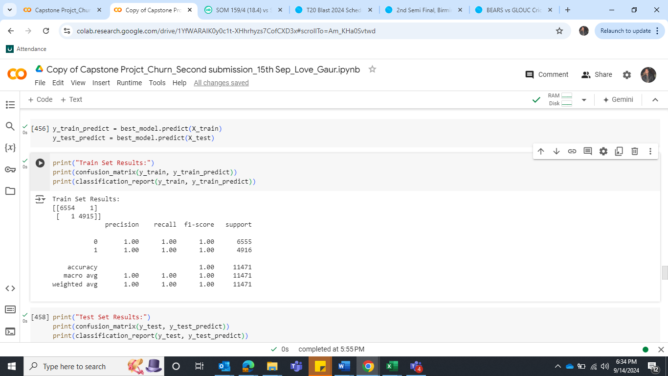 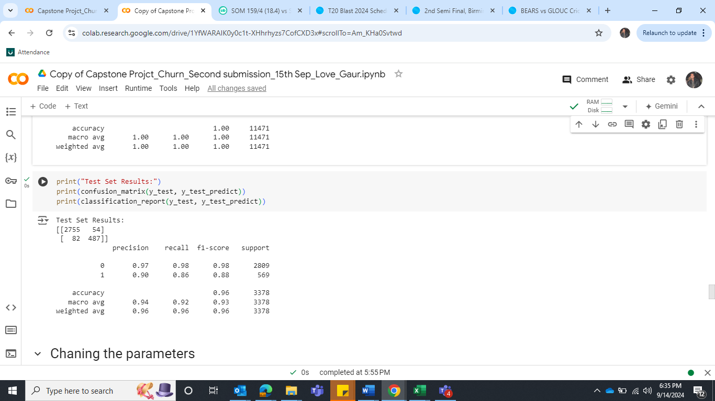

**Table 35: Confusion matrix and Classification Report of train and Test data**

**Insight**

The Precision, recall, F1-score and accuracy of train dataset was 1 which later dropped in dataset which indicates that model is overfitting. **Let’s try to change the parameters and fit the model again on the train and test dataset.**

**Changing the parameters**

param_grid = { 'n_estimators': [400], 'learning_rate': [0.3], 'max_depth': [5], 'min_samples_split': [2],  'min_samples_leaf': [5], 'subsample': [0.9]}

Here are the Best Parameters:

{'learning_rate': 0.3, 'max_depth': 5, 'min_samples_leaf': 5, 'min_samples_split': 2, 'n_estimators': 400, 'subsample': 0.9}

Let’s predict the train and test dataset.

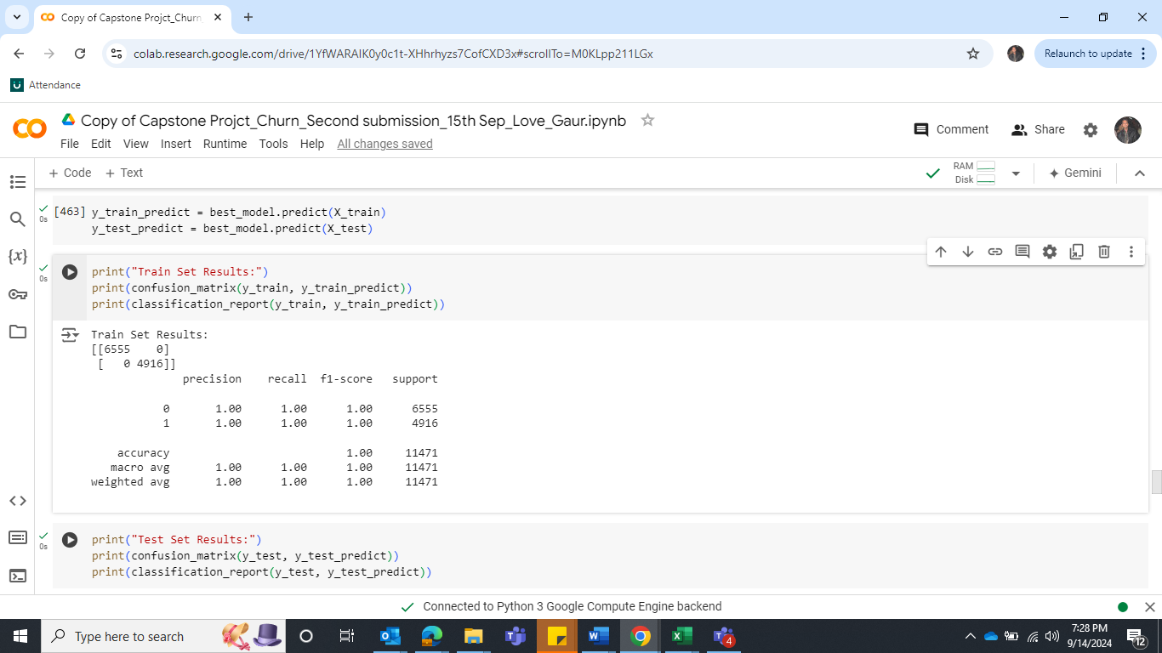 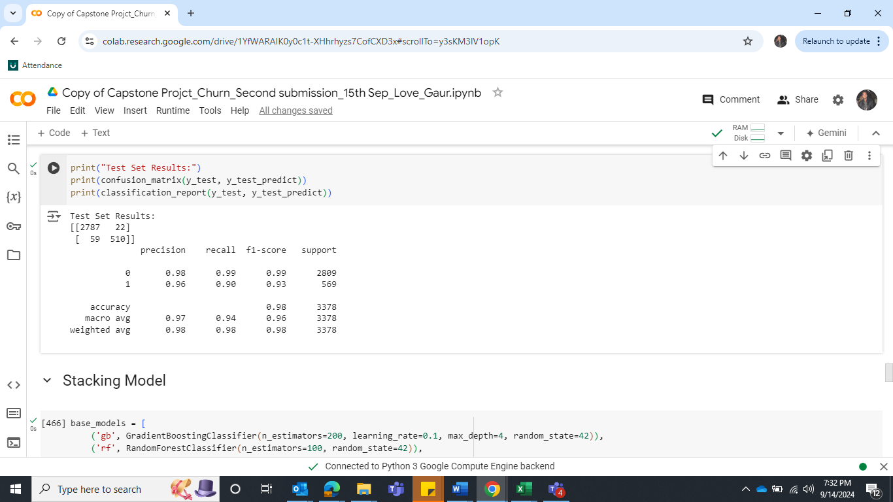

**Table 36: Confusion matrix and Classification Report of train and Test data**

**Insight**

The model has improved substantially after adjusting hyperparameters, especially in terms of test recall, precision, and F1 score. The model continues to perfectly fit the training data which indicates overfitting.

**1 – Accuracy:** The accuracy of the train dataset is 1 which dropped on test data set to 98. However, the accuracy of the test data set has increased after the tune.

**2 – Recall:** The recall value of train is 1 which dropped on test data set to 90. However, the recall value of test data set is increased after hyper tune.

**3 – Precision:** The precision value of the train is 1 which dropped on test data set to 96 which is very good, and it has improved after hyper tune.

**4 - F1 Score:** Both recall and precision are balanced well, with the final F1 score at 0.93 for the test set, indicating solid model performance.

***Overall, this model worked well with minor overfitting. Let’s check another model then will decide on final model.***

**Model 6 - Bagging**

Import BaggingClassifier from Sklearn.ensemble

Import the model, define the model and fit the model.

**Confusion Matrix and Classification report for the train and test data**

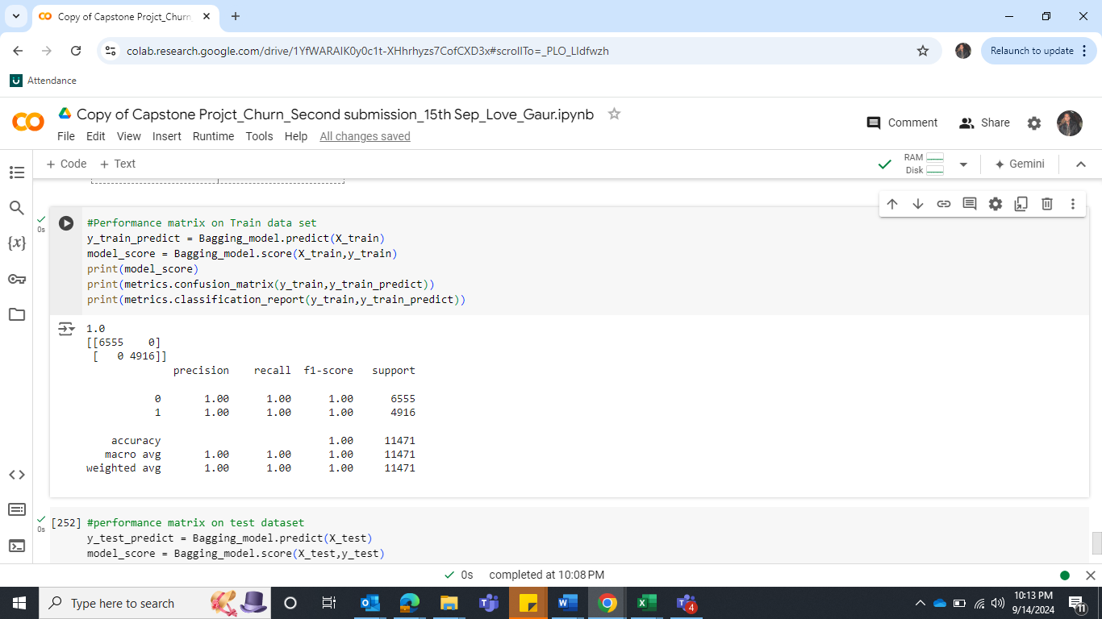 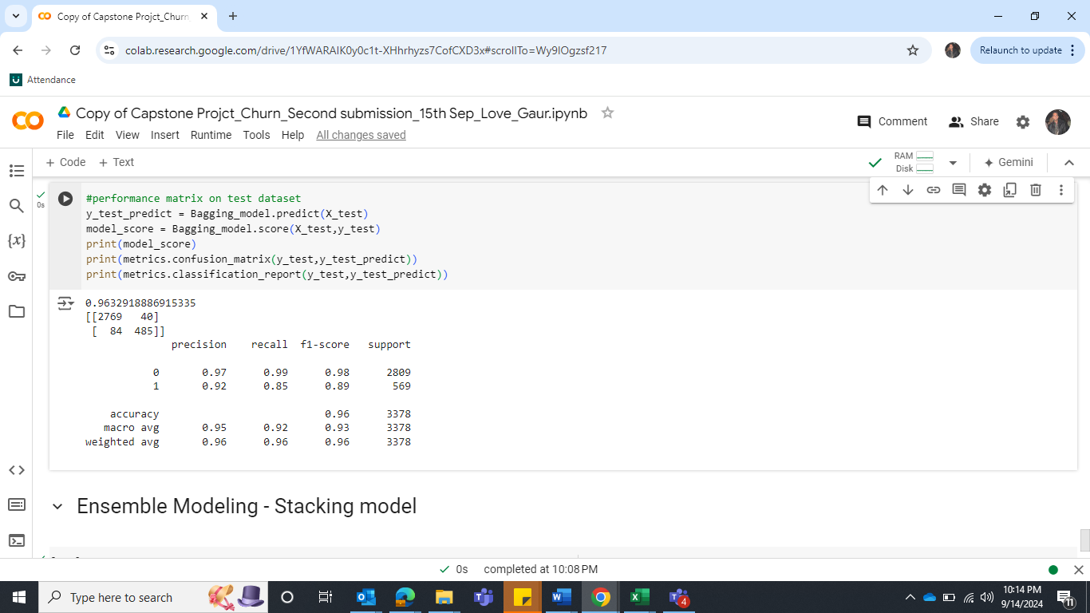

**Table 37: Confusion matrix and Classification Report of train and Test data**

**Insight** The model was able to identify all instances perfectly in train dataset as the recall, precision and accuracy is 1. However, it dropped in unseen data which indicates that the model is overfitting.

Let’s hyper tune the model.

**Hyper Tune the model**

We will tune the model with DecisionTreeClassifier(). Below are the parameters.

param_dist = { 'n_estimators': [50, 100, 200], 'max_samples': [0.8, 1.0], 'max_features': [0.8, 1.0], 'bootstrap': [True, False], bootstrap_features': [True, False],'base_estimator__max_depth': [None, 10, 20], 'base_estimator__min_samples_split': [2, 5, 10], 'base_estimator__min_samples_leaf': [1, 2, 4]}

**Here we have the best parameters.**

Best parameters from RandomizedSearchCV: {'n_estimators': 200, 'max_samples': 1.0, 'max_features': 0.8, 'bootstrap_features': True, 'bootstrap': False, 'base_estimator__min_samples_split': 5, 'base_estimator__min_samples_leaf': 1, 'base_estimator__max_depth': 20}

**Confusion Matrix and Classification report for the train and test data**

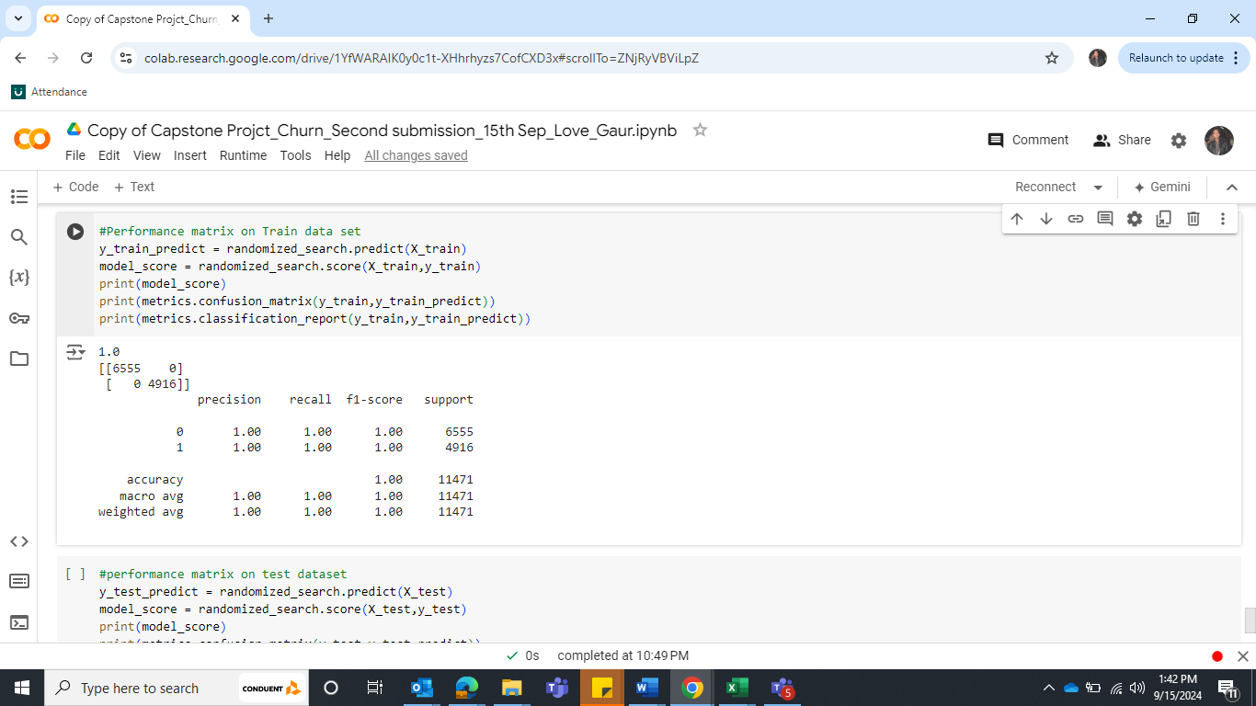 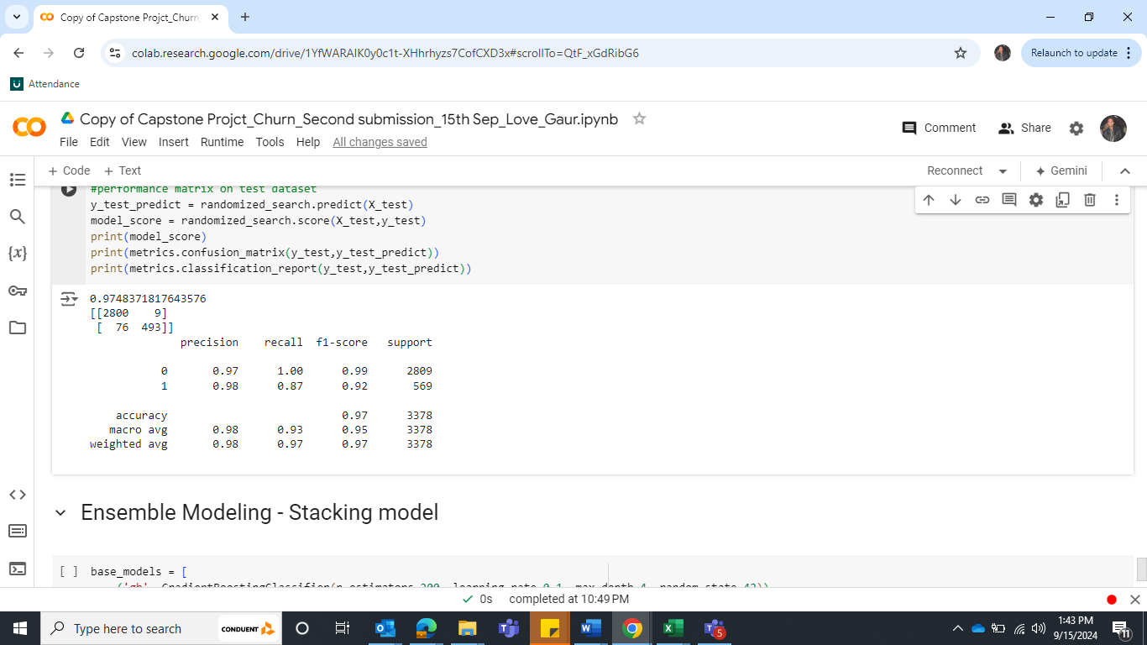

**Table 38: Confusion matrix and Classification Report of train and Test data**

**Insight -** The performance of the model has increased after hyper tune. The accuracy of class 1, recall of class 1, Precision and F1 score has increased in test data. However, in train data, it has excellent performance as value 1 for all the matrix shows that the model is overfit.

Select Best Model & mention reason:



**Table 39: Comparison table of all models**

As per the above table, we have built several models such as Logistic Regression, Naive Bayes, KNN, Random Forest, Ada Boosting, Gradient Boosting and Bagging. While building the model and test it on the unseen data. We noticed that the data was imbalanced, so we used SMOTE technique. To improve the model performance, we hyper tune the model, adjusted the parameters. After all the efforts, we came up with a final model is ***Gradient Boost After hyper tune adjusted parameters.***

**Accuracy:**

Training Accuracy: 1.00 and Test Accuracy: 0.98

Gradient Boost After hyper tune adjusted parameters achieves extremely good accuracies on the training, but it drops slightly on the test datasets.

**Recall of class "1":**

Training Recall of 1’s: 1.00 and Test Recall of 1’s: 0.90

The recall of class "1" represents the ability of the model to correctly identify instances belonging

to class "1" (e.g., churn). The recall value of train is extremely good, but it drops in test dataset, but still, it is 90 which is 10% deviation so we can consider it very good model on test dataset.

**Precision of class "1":**

Training precision of 1’s: 1.00 and Test precision of 1’s: 0.96

All the instances predicted as class 1, 100% were correct but it drops in test data set to 96%. It suggests that the model is making 4% incorrect predictions for class 1 in the test set.

**F1-score of class “1”:**

Training F1-score of 1’s: 1.00 and Test F1-score of 1’s: 0.93

The harmonic mean of precision and recall is good in train dataset but drops in test dataset.

**Area Under the ROC Curve (AUC):**

Training AUC: 1.00 and Test AUC: 0.99 - The AUC is on the train and test is very good.

***Gradient Boost after hyper tune adjusted parameters*** outperforms other models in terms of accuracy, recall of positive cases, and AUC score on both training and test sets.

Bagging (Hypertuning) also performs very well with slightly lower recall, but higher precision compared to Gradient Boost. Since our focus is on recall more, ***Gradient Boost after hyper tune adjusted parameters*** is our first choice.

Check the most important features in the final model and draw inferences.

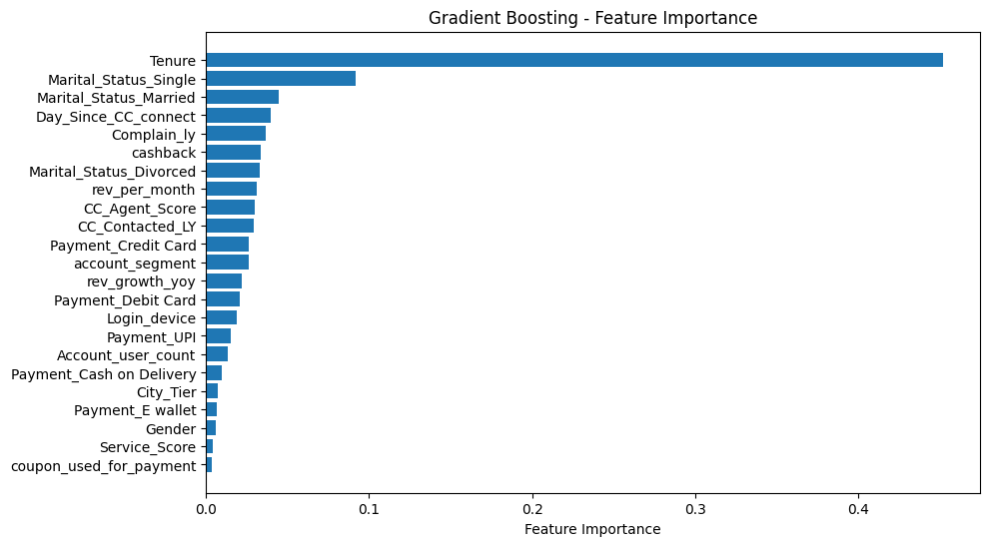

**Figure 59: Important features in final model**

**Observation - Tenure is the most important feature, followed by Marital status as per the tuned gradient boosting**

**model.**

Actionable Insights & Recommendations

1 - Churn Insights by City Tier and Payment method

1. Customers in Tier 1 cities are likely more using traditional payment methods like debit and credit cards and No E-Wallet Usage, the lack of E-Wallet usage suggests that Tier 1 customers either don’t see the need for them or prefer to stick with more traditional payment methods. E-wallets may not offer significant benefits to this group.
2. Tier 3 city customers are more inclined towards using **E-wallets**, likely due to the convenience and ease of use. These customers may have limited access to banking services or may prefer alternatives like E-wallets for smaller or day-to-day transactions. **Low UPI Usage**: UPI, although widely adopted in urban centers, might not be as common or preferred in Tier 3 cities due to either limited awareness, internet connectivity issues, or a preference for the simplicity of E-wallets over linking bank accounts for UPI transactions. This suggests a shift in behavior where customers are comfortable with mobile payments, but they may not fully trust or utilize the more direct forms of digital banking, like UPI.
3. In Tier 2 cities, UPI seems to be the dominant mode of payment. This shows that Tier 2 city customers are adopting more recent and tech-forward payment methods like UPI but have not embraced E-wallets. They might perceive UPI as more convenient or secure.
4. COD and E-wallet have a higher churn rate compared to other payment methods. This could be because COD might be associated with a higher risk of order cancellations or returns, leading to dissatisfaction or inconvenience for both customers and businesses. For E-Wallet, this could be due to issues such as limited acceptance, perceived lack of security, or dissatisfaction with e-wallet services.

2 - Churn Insights by Customer Segment

1. **Regular Plus Customers** - These customers have the highest likelihood of churning. This could be due to several factors such as Value Perception (They may feel they are not receiving enough value relative to their spending or benefits), Service Expectations (They might have high expectations that are not being met, leading to dissatisfaction), Competition (They might be more inclined to switch to competitors offering better deals or services).
2. **HNI (High Net-Worth Individuals)** - HNI customers are also more likely to churn due to Personalized Service (HNIs often expect highly personalized and premium services. Any shortfall in meeting these expectations could lead to higher churn), Exclusive Offers (They might be more tempted by exclusive offers from competitors, leading to higher churn rates if those offers are more attractive).
3. **Super Plus & Regular Customers** - These customers have a lower churn rate compared to Regular Plus and HNI but a moderate rate. This suggests they will likely receive a good balance of value and service, which keeps them engaged, they are likely content with their current level of service and benefits, leading to higher retention.
4. **Super Customers -** Super customers have a moderate churn rate. They are more stable than Regular Plus and HNI but not as secure as Regular customers. This might be due to Service Quality and Competitive Pressure.

3 – Other insights

1. Single people are more to churn, are more than **50%** of the churn group, indicating they are the most at risk for leaving. This could be due to their lifestyle flexibility or willingness to explore other services or products.
2. Customers who have small tenure are more likely to churn.
3. Males are slightly more likely to churn compared to females. Males might be more inclined to explore competitive alternatives or might be less satisfied with their current service, leading to higher churn.

Business recommendations:

City Tier and Payment Method

**Tier 1 City Customers**

1. To encourage continued loyalty, offer incentives such as cashback or discounts for customers using debit or credit cards.
2. Launch awareness campaigns highlight the benefits of using e-wallets (e.g., faster transactions, exclusive offers). Collaborate with e-wallet providers to offer promotions tailored to Tier 1 customers, emphasizing convenience and security.

**Tier 3 City Customers:**

1. Continuing offering and improving e-wallet-based offers and promotions, as these customers are more inclined to use them.
2. **Educate on UPI Benefits:** Conduct awareness campaigns or workshops about the ease and security of UPI payments to increase its adoption in Tier 3 cities. Offering simple guides or incentives for first-time UPI users may also encourage adoption.

**Tier 2 City Customers:**

1. Focus on promoting UPI-related discounts, cashback, or other rewards, as these customers have embraced the convenience of UPI.

**COD and E-Wallet Usage:**

1. Introduce incentives for prepaid transactions or offer faster delivery and easier returns for prepaid orders to shift away from COD and reduce risks of order cancellations.
2. Partner with more merchants to increase the acceptance of e-wallets and resolve potential user issues, such as security concerns or limited usability.

Customer Segment

**Regular Plus Customers:**

1. Increase Value Perception: Offer personalized rewards, exclusive offers, or better loyalty points to Regular Plus customers. Highlight the additional benefits of staying loyal, such as priority customer service or access to premium features.
2. Monitor Satisfaction: Implement frequent satisfaction surveys or engagement tracking to proactively address any dissatisfaction before it leads to churn.

**High Net-Worth Individuals (HNIs):**

1. Invest in customer relationship management to offer tailored services for HNIs. This could include dedicated relationship managers, exclusive events, or personalized financial or service advice.
2. Create Exclusive Offers.

**Super Plus & Regular Customers:**

1. Ensure that customer service and product offerings remain consistent to retain these customers

**Super Customers:**

1. Reassess pricing, customer service, and product offerings for this segment to prevent competitors from drawing them away. Offering regular updates on new features or improvements can keep them engaged.

Demographic and Behavioral

**Single People:** More likely to churn, offer flexible pricing plans or services that cater to the lifestyle of single individuals. Ensure engagement through personalized offers, tailored communications, and targeted messaging around convenience or excitement.

**Short Tenure Customers:** Create a seamless and engaging onboarding process for new customers. Provide extra attention in the first 3-6 months with special welcome offers, product tutorials, and proactive support to help them fully realize the value of your service.

**Males:** Males are slightly more likely to churn than females. Personalize communication and offers to target male customers based on their preferences. Competitive pricing and innovative product features may help retain their interest.